Regional Information Report No. 1J25-23
2026 Northern Southeast Inside Subdistrict Sablefish Management Plan and Stock Assessment
by
Aaron W. Lambert
and
Rhea K. Ehresmann

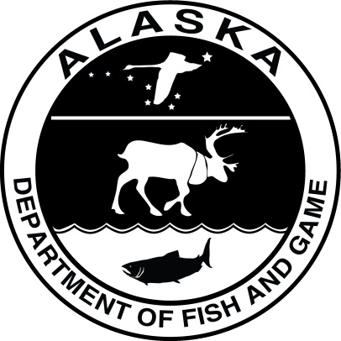
July 2025
Alaska Department of Fish and Game Division of Commercial Fisheries
Symbols and Abbreviations
The following symbols and abbreviations, and others approved for the Système International d'Unités (SI), are used without definition in the following reports by the Divisions of Sport Fish and of Commercial Fisheries: Fishery Manuscripts, Fishery Data Series Reports, Fishery Management Reports, and Special Publications. All others, including deviations from definitions listed below, are noted in the text at first mention, as well as in the titles or footnotes of tables, and in figures or figure captions.

Weights and measures (metric)
centimeter cm
deciliter dL
gram g
hectare ha
kilogram kg
kilometer km
liter L
meter m
milliliter mL
millimeter mm

Weights and measures (English)
cubic feet per second ft³/s
foot ft
gallon gal
inch in
mile mi
nautical mile nmi
ounce oz
pound lb
quart qt
yard yd

Time and temperature
day d
degrees Celsius °C
degrees Fahrenheit °F
degrees kelvin K
hour h
minute min
second s

Physics and chemistry
all atomic symbols
alternating current AC
ampere A
calorie cal
direct current DC
hertz Hz
horsepower hp
hydrogen ion activity pH
(negative log of)
parts per million ppm
parts per thousand ppt,
‰
volts V
watts W
General
Alaska Administrative
Code AAC
all commonly accepted
abbreviations e.g., Mr., Mrs., AM, PM, etc.
all commonly accepted
professional titles e.g., Dr., Ph.D.,
R.N., etc.
at @
compass directions:
east E
north N
south S
west W
copyright ©
corporate suffixes:
Company Co.
Corporation Corp.
Incorporated Inc.
Limited Ltd.
District of Columbia D.C.
et alii (and others) et al.
et cetera (and so forth) etc.
exempli gratia
(for example) e.g.
Federal Information
Code FIC
id est (that is) i.e.
latitude or longitude lat or long
monetary symbols
(U.S.) $, ¢
months (tables and
figures): first three
letters Jan,...,Dec
registered trademark ®
trademark ™
United States
(adjective) U.S.
United States of
America (noun) USA
U.S.C. United States Code
U.S. state use two-letter abbreviations (e.g., AK, WA)
Mathematics, statistics
all standard mathematical
signs, symbols and
abbreviations
alternate hypothesis H_{A}
base of natural logarithm e
catch per unit effort CPUE
coefficient of variation CV
common test statistics (F, t, χ², etc.)
confidence interval CI
correlation coefficient
(multiple) R
correlation coefficient
(simple) r
covariance cov
degree (angular) °
degrees of freedom df
expected value E
greater than >
greater than or equal to ≥
harvest per unit effort HPUE
less than <
less than or equal to ≤
logarithm (natural) ln
logarithm (base 10) log
logarithm (specify base) log_{2,} etc.
minute (angular) ′
not significant NS
null hypothesis H_{O}
percent %
probability P
probability of a type I error
(rejection of the null
hypothesis when true) α
probability of a type II error
(acceptance of the null
hypothesis when false) β
second (angular) ″
standard deviation SD
standard error SE
variance
population Var
sample var

Regional Information report No. 1J25-23
2025 NORTHERN SOUTHEAST INSIDE SUBDISTRICT SABLEFISH management plan and Stock Assessment
by

Spencer Y. Weinstein
Alaska Department of Fish and Game, Division of Commercial Fisheries, Juneau

Alex G. Reich
Alaska Department of Fish and Game, Division of Commercial Fisheries, Juneau

Caitlin A. Stern
Alaska Department of Fish and Game, Division of Commercial Fisheries, Juneau

and

Rhea K. Ehresmann
Alaska Department of Fish and Game, Division of Commercial Fisheries, Sitka

Alaska Department of Fish and Game
Division of Commercial Fisheries
802 3rd, Douglas, Alaska, 99824-0020
July 2025

The Regional Information Report Series was established in 1987 and was redefined in 2007 to meet the Division of Commercial Fisheries regional need for publishing and archiving information such as area management plans, budgetary information, staff comments and opinions to Alaska Board of Fisheries proposals, interim or preliminary data and grant agency reports, special meeting or minor workshop results and other regional information not generally reported elsewhere. Reports in this series may contain raw data and preliminary results. Reports in this series receive varying degrees of regional, biometric and editorial review; information in this series may be subsequently finalized and published in a different department reporting series or in the formal literature. Please contact the author or the Division of Commercial Fisheries if in doubt of the level of review or preliminary nature of the data reported. Regional Information Reports are available through the Alaska State Library and on the Internet at: http://www.adfg.alaska.gov/sf/publications/.
Product names used in this publication are included for completeness and do not constitute product endorsement. The Alaska Department of Fish and Game does not endorse or recommend any specific company or their products.

Spencer Weinstein, Alex Reich, Caitlin Stern
Alaska Department of Fish and Game, Division of Commercial Fisheries,
1255 W. 8th Street, Juneau, AK 99801, USA

and

Rhea Ehresmann
Alaska Department of Fish and Game, Division of Commercial Fisheries,
304 Lake Street, Room 103, Sitka, AK 99835, USA

This document should be cited as follows:
Weinstein, S. Y., A. G. Reich, C. A. Stern, and R. K. Ehresmann. 2025. 2025 Northern Southeast Inside Subdistrict sablefish management plan and stock assessment. Alaska Department of Fish and Game, Division of Commercial Fisheries, Regional Information Report No. 1J25-23, Douglas.
The Alaska Department of Fish and Game (ADF&G) administers all programs and activities free from discrimination based on race, color, national origin, age, sex, religion, marital status, pregnancy, parenthood, or disability. The department administers all programs and activities in compliance with Title VI of the Civil Rights Act of 1964, Section 504 of the Rehabilitation Act of 1973, Title II of the Americans with Disabilities Act (ADA) of 1990, the Age Discrimination Act of 1975, and Title IX of the Education Amendments of 1972.
If you believe you have been discriminated against in any program, activity, or facility please write:
ADF&G ADA Coordinator, P.O. Box 115526, Juneau, AK 99811-5526
U.S. Fish and Wildlife Service, 4401 N. Fairfax Drive, MS 2042, Arlington, VA 22203
Office of Equal Opportunity, U.S. Department of the Interior, 1849 C Street NW MS 5230, Washington DC 20240
The department’s ADA Coordinator can be reached via phone at the following numbers:
(VOICE) 907-465-6077, (Statewide Telecommunication Device for the Deaf) 1-800-478-3648,
(Juneau TDD) 907-465-3646, or (FAX) 907-465-6078
For information on alternative formats and questions on this publication, please contact:
ADF&G, Division of Sport Fish, Research and Technical Services, 333 Raspberry Rd, Anchorage AK 99518 (907) 267-2517

TABLE OF CONTENTS
Page
LIST OF TABLES ii
LIST OF FIGURES ii
LIST OF Appendices iii
ABSTRACT 1
INTRODUCTION 1
2025 SABLEFISH MANAGEMENT PLAN 2
ANNUAL HARVEST OBJECTIVE DETERMINATION 2
Bycatch mortality in the halibut fishery 2
ADF&G longline survey removals 2
Sport fish harvest (guided and unguided) 3
Mortality from fishery deadloss 3
Personal use and subsistence harvest 3
REGULATIONS 3
2025 Board of Fisheries – Regulatory Changes 3
Registration and logbook requirements 4
Tagged sablefish 4
Sablefish possession and landing requirements 4
Fish ticket requirements 4
Bycatch allowances for other species 5
Sablefish live market 5
Prohibitions 5
2024 SABLEFISH STOCK ASSESSMENT AND 2025 RECOMMENDED ABC 6
CHANGES TO THE 2025 NSEI ASSESSMENT RELATIVE TO 2024 9
MODEL STRUCTURE 10
DATA INPUTS 10
MODEL PARAMETERS 15
POPULATION DYNAMICS 16
PREDICTED VALUES 16
BIOLOGICAL REFERENCE POINTS 18
LIKELIHOOD COMPONENTS 19
MODEL RESULTS 21
Retrospective analysis 23
ABC RECOMMENDATIONS 23
FUTURE WORK AND RECOMMENDATIONS 24
ACKNOWLEDGEMENTS 25
REFERENCES CITED 25
TABLES AND FIGURES 29
APPENDIX A: MODEL PARAMETERS, DEFINITIONS, AND DATA SOURCES 63

LIST OF TABLES
Table Page
1. Summary of key assessment results used to inform management in 2024 and 2025. 30
2. Annual harvest objective (round lb), equal quota share (EQS; round lb), reported harvest (round lb), exvessel value, number of permits, and effort (days) for the directed commercial Northern Southeast Inside (NSEI) Subdistrict sablefish fishery, 1985–2025. 31
3. Sablefish ABC, model decrement types and amounts, 2020–2025. 32
4. Variable definitions for the statistical catch-at-age model, indexing and model dimensions. 33
5. Variable definitions for the statistical catch-at-age model, parameters. 34
6. A summary of data inputs to the mark–recapture models, 2005–2022. 35
7. Statistical catch-at-age model parameter estimates for NSEI sablefish model. 36
8. Negative likelihood (NLL) values and percent of each component to the total likelihood (% of NLL) for NSEI sablefish model. 37

LIST OF FIGURES
Figure Page
1. Northern Southeast Inside (NSEI) Subdistrict including restricted waters of Glacier Bay National Park and Preserve. 38
2. Catch, landings by port, and exvessel value for Northern Southeast Inside (NSEI) Subdistrict commercial sablefish 1985–2024. 39
3. Estimated catch in the Northern Southeast Inside (NSEI) Subdistrict fishery from 2000–2024 and the relationship to F₄₀, F₅₀ and F₆₀ (F_{spr}). 40
4. Mohn’s ρ and retrospective peels of estimated sablefish spawning biomass. 41
5. Comparison of the mean length and age in the longline (LL) and pot fisheries and longline survey since 1997 for male and female sablefish in the Northern Southeast Inside (NSEI) Subdistrict.. 42
6. Biological inputs to the statistical catch-at-age model, including: (A) von Bertalanffy growth model predictions of weight-at-age (kg) by sex from the longline fishery (gold), pot fishery (brown), and ADF&G longline survey (red), and (B) proportion mature at age for females estimated from the longline survey with the age at 50% maturity (a₅₀ = 5.7 yr) indicated by the dashed grey line. 43
7. Changes in maturity-at-age (top panel) and -length (bottom panel) over time in the Northern Southeast Inside (NSEI) Subdistrict sablefish population, showing a general trend of fish maturing at younger ages and smaller sizes. 44
8. Indices of catch and abundance with the assumed error distribution, including: (A) harvest (round mt); (B) fishery catch per unit effort in round lb per hook; (C) survey catch per unit effort in number of fish per hook; and (D) mark–recapture abundance estimates in millions. 45
9. Nominal (blue) versus fully standardized (red) catch per unit effort (CPUE) in the NSEI Subdistrict longline sablefish fishery in round lb per hook. . 46
10. Fishery age compositions by sex for the Northern Southeast Inside (NSEI) Subdistrict longline fishery (2002–2024, top row) and ADFG longline survey (1997–2024, bottom row). 47
11. Longline fishery, pot fishery, and survey length distributions by sex from 1997–2024. 48
12. Probability of retaining a fish as a function of weight (top), sex, and age (bottom). 49
13. Fishery selectivity (top): fixed age-based selectivity curves for the fishery before the Equal Quota Share (EQS) program started in 1994 (pre-EQS), the fishery since the implementation of EQS while it was solely longline gear (1995–2021), the fishery since it became a mixed gear fishery (2022-present). 50
14. Probability of retaining a fish as a function of weight (top), sex, and age (bottom). 51
15. Fits to indices of catch and abundance with the assumed error distribution shown as shaded grey polygons.. 51
16. Model predictions of (A) age-2 recruitment (millions); (B) female spawning stock biomass (million pounds); (C) exploitable abundance (millions); and (D) exploitable biomass (million pounds). 52
17. Fits to fishery age compositions, 2002–2024. 53
18. Fits to survey age compositions, 1997–2024. 54

LIST OF FIGURES (Continued)
Figure Page
19. Standardized residuals of fits to fishery (2002–2024) and survey (1997–2024) age compositions... 55
20. Fits to male fishery length compositions, 2002–2024. 56
21. Fits to female fishery length compositions, 2002–2024. 57
22. Fits to male survey length compositions, 1997–2024. 58
23. Fits to female survey length compositions, 1997–2024. 59
24. Standardized residuals of fits to fishery (2002–2024) and survey (1997–2024) length compositions for males and females. 60
25. Mohn’s ρ and retrospective peels of estimated sablefish recruitment. 61
26. Model-estimated fishing mortality rate (top) and realized harvest rate (bottom), defined as the ratio of total predicted catch to exploitable biomass. 62

LIST OF Appendices
Appendix Page
A1. Variable definitions for the statistical catch-at-age model, indexing and model dimensions, data and predicted values. 65
A2. Assumed selectivity parameters for the NSEI sablefish fishery for females and males. 66
A3. Summary of the available data sources in the Northern Southeast Inside (NSEI) Subdistrict by year. 67

ABSTRACT
This report provides an overview of the stock assessment, harvest strategy, and regulations effective for the 2026 Northern Southeast Inside (NSEI) sablefish Anoplopoma fimbria commercial fishery. The NSEI sablefish commercial fishery is scheduled to open August 15 and close November 15 and is open to both longline and pot gear. The 2026 NSEI sablefish commercial fishery annual harvest objective is 1,789,671 round lb and is based on decrements from an acceptable biological catch of 2,080,436 round lb. The annual harvest objective is allocated to 73 limited entry Commercial Fisheries Entry Commission C61A permits through an equal quota share system, resulting in a 2026 equal quota share of 24,516 round lb for each permit holder.
Keywords: sablefish, black cod, Anoplopoma fimbria, stock assessment, annual harvest objective, AHO, catch per unit effort, CPUE, Northern Southeast, Chatham Strait, NSEI, mark–recapture, tagging

INTRODUCTION
The Alaska Department of Fish and Game (ADF&G) evaluates sablefish Anoplopoma fimbria stock status and establishes the Northern Southeast Inside (NSEI) acceptable biological catch (ABC) and subsequent annual harvest objective (AHO). The NSEI Subdistrict management area (Figure 1) consists of all waters as defined in 5 AAC 28.105(a)(2).
The recommended 2026 ABC for sablefish is 2,080,436 round lb (F_{ABC} = 0.061), a 15% increase from the 2025 ABC (Table 1). After making decrements for sablefish mortalities in other fisheries, the 2025 NSEI Subdistrict commercial sablefish fishery AHO is 1,789,671 round lb (Tables 2 and 3). There are 73 valid Commercial Fisheries Entry Commission (CFEC) permits for 2026, which is the same number as 2025. The individual equal quota share (EQS) is 24,516 round lb, a 16% increase from the 2025 EQS of 21,129 round lb (Table 2).
The increase in the ABC is attributed to the continued growth and maturation of the year classes since 2015. This growth is highlighted by strong recruitment in 2018 (the 2016 year class), which is the highest recruitment since 1979. The dominant 2016 year class is now over 50% mature and will comprise over 32% of the biomass. The data indicate that the large recruitments between 2015 and 2019 were underestimated in assessments prior to 2024, and more informed estimation of those recruitments has led to increased estimated spawning biomass in the 2024 and 2025 assessments. This variance is common in age-structured assessments, as it takes multiple years of cohort observations to bring into focus the true size of a recruitment event. There was no mark–recapture experiment in 2024. Catch per unit effort (CPUE) estimates from the 2024 fishery were lower than in 2023, while CPUE estimates from the 2024 longline survey increased from the 2023 survey CPUE; both fishery and survey CPUE estimates remain above their respective long-term averages. Catches increased in 2024 as the 2013 through 2018 year classes reached marketable size, and ex-vessel value increased 17.8% from 2023 (2024 assessment). However, fishery catch and ex-vessel values remain depressed in comparison to historical values (Table 2, Figure 2), and estimates suggest sablefish spawning stock biomass remains at lower levels compared to the 1980s and 1990s. Though recent high catch rates of small sablefish across multiple geographic areas signal increasing trends for sablefish stocks (Goethel et al. 2022), the department maintains a precautionary approach to setting harvest limits.
The ABC determination process uses a statistical catch-at-age model, which was first implemented in 2020. The model reduces the reliance on the annual mark–recapture project to estimate recruitment, abundance, and spawning stock biomass of NSEI sablefish by integrating multiple indices of abundance and biological data. Data sources used in the model include catch, mark–recapture abundance estimates, longline survey and fishery CPUE, and longline survey and fishery length and age compositions. As in previous years, the ABC is defined by $F_{50}$, the fishing mortality rate that reduces spawning biomass to 50% of equilibrium unfished levels.
The process ADF&G uses to determine the ABC, AHO, and EQS includes compiling fishery and survey data, running the stock assessment, and accounting for additional sources of mortality through decrements. Although the ABC is determined prior to the AHO and EQS, this report is organized to make management-related information accessible to stakeholders and improve documentation of the assessment process by organizing this report into sections:
- 2025 Sablefish Management Plan: details the decrements process leading to the AHO and EQS and effective regulations for the 2025 NSEI fishery
- 2024 Sablefish Stock Assessment and 2025 ABC Determination: highlights stock assessment data inputs, methods, results, and subsequent analyses using data from the 2024 fishery that informed the recommended ABC for the 2025 fishing season

2025 SABLEFISH MANAGEMENT PLAN

ANNUAL HARVEST OBJECTIVE DETERMINATION
The 2025 sablefish AHO was determined by making the following decrements from the recommended ABC (2,080,436 round lbs; Tables 2 and 3):
- estimated sablefish bycatch mortality in the commercial Pacific halibut Hippoglossus stenolepis fishery
- ADF&G longline and pot survey removals
- sport fishery guided and unguided harvest
- mortality from fishery deadloss
- subsistence and personal use harvest

Bycatch mortality in the halibut fishery
Sablefish caught in NSEI during the Pacific halibut individual fishing quota (IFQ) fishery prior to the sablefish fishery opening (August 15) must be released; however, because not all are expected to survive, bycatch mortality is estimated. Prior to 2003, a 50% bycatch mortality rate was applied as bycatch sablefish were permitted to be retained as bait. In 2003, the Alaska Board of Fisheries disallowed retaining bycatch sablefish for bait, and a 25% bycatch mortality rate was assumed for all sablefish caught and released due to the larger hook size in the Pacific halibut fishery. Released sablefish bycatch is calculated as the product of the 3-year average of the sablefish to Pacific halibut ratio from the International Pacific Halibut Commission (IPHC) annual survey and the 3-year average of the Pacific halibut catch in NSEI areas deeper than 99 fathoms.

ADF&G longline survey removals
Permit holders will likely not participate in the NSEI longline and pot survey in 2025 due to low sablefish prices and the need to stabilize survey revenue as the project is experiencing ongoing budgetary deficits (Table 3, Figure 2). The survey removal decrement was determined by calculating the average survey total harvest from the previous 3 years.

Sport fish harvest (guided and unguided)
Sablefish sport fish preliminary harvest and release mortality from the guided and unguided sectors are estimated using charter logbooks and the statewide harvest survey (Romberg et al. 2017). Estimates of harvested and released fish are based on the total number of fish and converted to weight using a 3-year average weight of fish sampled from the guided and unguided sectors. A 10% release mortality rate is applied to the sport fishery; this rate was based on the 11.7% estimated in Stachura et al. (2012) and modified to account for difference in gear type (rod and reel versus longline) and handling time.

Mortality from fishery deadloss
Deadloss mortality in the directed sablefish fishery was estimated by applying the percentage of dead sablefish (i.e., recorded as predated by sand fleas, sharks, hooking injury, or other cause of mortality) caught on the NSEI longline survey using the recent 3-year average, 0.36% (2022–2024), to the NSEI sablefish commercial AHO.

Personal use and subsistence harvest
A total of 902 personal use and subsistence sablefish permits were issued in 2024. Annual subsistence and personal use harvest of sablefish is estimated from these permits by adding the total number of retained sablefish reported to the proportion of released sablefish reported after applying a 16% discard mortality rate to released sablefish (Gilroy and Stewart 2013). The discard mortality rate comes from the discard mortality rate used in the Pacific halibut fishery, which is assumed to be a reasonable proxy for sablefish because the fisheries utilize similar gear and frequently the same vessels and crew participate in both fisheries. Also, both species are considered resilient and do not experience barotrauma. The 2024 longline survey average weight (5.7 lb) was applied to the harvest and release numbers to obtain a decrement total.
From 2015 to the present, personal use harvest is limited annually to 50 fish per household. Since 2018, participants of the personal use fishery have been allowed to use pot gear with no more than 2 pots per permit and a maximum of 8 pots per vessel when 4 or more permit holders are on board the same vessel. Pots may now be longlined in this fishery.

REGULATIONS

2025 Board of Fisheries – Regulatory Changes
In January 2025, the Alaska Board of Fisheries adopted new regulations that are effective June 27, 2025, and will apply during the fishing season for the NSEI sablefish commercial fishery. New regulations include:
- Additional logbook requirements for vessels fishing for groundfish with pot and longline gear.
- Reduction of the minimum inside diameter of circular escape rings from 3.75 inches to 3.5 inches in sablefish pots.
- Vessels or permit holders participating in the NSEI commercial sablefish fishery are prohibited from operating any commercial, subsistence, sport, or personal use halibut or groundfish gear in state internal waters during the 72 hours before the fishery opens, during the fishery, and for 72 hours after it closes—unless specific exemptions are met.

Registration and logbook requirements
Commercial fishers must register prior to fishing [5 AAC 28.106 (b)] and keep a logbook during the fishery. Completed logbook pages must be attached to the ADF&G copy of the fish ticket at the time of delivery. Confidential envelopes for logbook pages may be requested when registering.
Permit holders will receive a personal quota share (PQS) tracking form at the time of registration. This form is used to record the total round weight landed for each delivery. Each permit holder must, upon request, provide the buyer with the total round weight of sablefish the permit holder has landed to date. ADF&G requests that a copy of the completed PQS tracking form is included with the final fish ticket of the season for that permit.
Logbooks must include the trip target species, port of landing, the date the vessel left port and the date the vessel landed, crew size, bait used, and gear specifications. For each set, the logbook must include:the set’s target species; the date and time gear is set and retrieved; the specific location of harvest by latitude and longitude for start and ending positions; the hook spacing; the amount of gear (number of hooks, skates, or pots) used; the amount of gear lost or impacted by depredation; the depth of set; the estimated number or weight of the target species; the estimated number or weight of bycatch by species retained and released at sea; and the tag number of any tagged fish captured [5 AAC 28.175 (b)(1)]. A permit holder must retain all visibly injured or dead sablefish. Sablefish that are not visibly injured or dead may be released unharmed, and the permit holder must record in the logbook, by set, the number of live sablefish released [5 AAC 28.170 (f)]. Permit holders must record release reason (e.g., fish are small) and whether their personal quota share has been met.

Tagged sablefish
Fishers are requested to watch for tagged sablefish, record tag number(s), and attach tags directly in the logbook with the corresponding set information. All tags returned will receive a reward which includes a t-shirt or hat and entry into an annual drawing for one $1,000, two $500, and four $250 cash rewards. To qualify for entry in the annual drawing, ADF&G requires the following information: the physical tag, set location (latitude and longitude), date of capture of the fish, and the name and address of the person recovering the tag.

Sablefish possession and landing requirements
In the NSEI Subdistrict, the holder of a CFEC permit for sablefish may not retain more sablefish from the directed fishery than the annual allocation of sablefish EQS specified by ADF&G [5 AAC 28.170 (f)]. However, if a permit holder’s harvest exceeds the EQS for that year by no more than 5%, ADF&G shall reduce the permit holder's EQS for the following year by the amount of overage. If a permit holder's harvest exceeds the permit holder's EQS by more than 5%, the proceeds from the sale of the overage in excess of 5% shall be surrendered to the state and the permit holder may be prosecuted under AS 16.05.723 [5 AAC 28.170 (j)]. If a permit holder’s harvest is less than the permit holder’s EQS established for the year, ADF&G shall increase the permit holder’s PQS only for the following year by the amount of the underage that does not exceed 5% of the EQS [5 AAC 28.170 (k)]. For the 2025 fishing season, 5% of the annual EQS is 1,226 round lb.

Fish ticket requirements
Landed weights must be recorded on a fish ticket at the time of delivery. If a fisher delivers fish in the round, the total round weight delivered must be recorded on the fish ticket. If a fisher delivers dressed fish, the fish ticket must include the total landed dressed weight as well as the round weight equivalent, determined by using the standard 0.63 recovery rate. There is a 2% allowance for ice and slime when unrinsed whole iced sablefish are weighed. A fish ticket must be completed prior to the resumption of fishing and each permit holder must retain, on board their vessel, copies of all NSEI sablefish tickets from the current season and their updated PQS tracking form. When delivering fish out of state, a completed fish ticket must be submitted to ADF&G prior to transporting fish out of Alaska.

Bycatch allowances for other species
Full retention and reporting of rockfish, including thornyhead rockfish, is required [5 AAC 28.171 (a)]. The allowable bycatch that may be legally landed and sold on an NSEI sablefish permit is based on round weight of sablefish and bycatch species or species group on board the vessel:
- All rockfish, including thornyheads: 15% in aggregate, of which 1% may be demersal shelf rockfish (DSR), which includes yelloweye, quillback, canary, tiger, copper, China, and rosethorn rockfish
- Lingcod: 0%
- Pacific cod: 20%
- Spiny dogfish: 35% longline/hook and line gear; 20% pot gear
- Other groundfish: 20%
All rockfish retained in excess of allowable bycatch limits shall be reported as bycatch overage on an ADF&G fish ticket. All proceeds from the sale of excess rockfish bycatch shall be surrendered to the state.
A CFEC permit holder fishing for groundfish must retain all Pacific cod when the directed fishery for Pacific cod is open and up to the maximum retainable bycatch amount (20%) of Pacific cod when a directed fishery for Pacific cod is closed [5 AAC 28.070 (e)]. Pacific cod taken in excess of the bycatch limit in areas open to directed fishing for Pacific cod may be landed on a CFEC miscellaneous saltwater finfish permit designated for the gear that was used. Fishers with halibut IFQ in regulatory area 2C and a CFEC halibut permit card must retain all halibut over 32 inches in length, up to the amount of their IFQ.

Sablefish live market
The holder of a CFEC or interim use permit for sablefish may possess live sablefish for delivery as live product except that, upon the request of a local representative of ADF&G or law enforcement, a permit holder must present sablefish for inspection and allow biological samples to be taken [5 AAC 28.170 (l)].

Prohibitions
The operator of a fishing vessel may not take sablefish in the NSEI area with sablefish from another area on board. Also, the operator of a vessel taking sablefish in the NSEI area shall unload those sablefish before taking sablefish in another area [5 AAC 28.170 (a) and (b)].
A vessel or CFEC permit holder onboard a vessel that participates in a commercial sablefish fishery in the NSEI or Southern Southeast Inside (SSEI) Subdistricts may not operate subsistence, sport, or personal use halibut or groundfish fishing gear during the 72 hours immediately before the start of the commercial sablefish fishery in that subdistrict [5 AAC 28.180 (a)]. A vessel or CFEC permit holder onboard a vessel that participates in a commercial sablefish fishery in the NSEI or SSEI Subdistricts may not operate subsistence, sport, or personal use halibut or groundfish fishing gear during a commercial sablefish opening or during the 72 hours immediately following the closure of a commercial sablefish fishery in that subdistrict unless the vessel or CFEC permit holder is not registered for the commercial sablefish fishery in that subdistrict; the vessel or CFEC permit holder has harvested their EQS and at least 72 hours have passed since the commercially harvested sablefish were offloaded from the vessel; commercial fishing gear used in the commercial fishery by the vessel or the CFEC permit holder onboard a vessel has been removed from the water for at least 72 hours; or at least 72 hours have passed since the vessel owner, or owner’s agent, has contacted a local representative of the department and requested that the department cancel the vessel’s commercial sablefish registration, and the department has canceled the vessel’s commercial sablefish registration [5 AAC 28.180 (b)].

2024 SABLEFISH STOCK ASSESSMENT AND 2025 RECOMMENDED ABC
Sablefish are a highly migratory, long-lived species broadly distributed in the North Pacific Ocean. Although research to date suggests that sablefish comprise a single, panmictic population, they are managed as separate stocks in Alaska state and federal waters, British Columbia, and in state and federal waters off the U.S. west coast. After three decades of declining or suppressed spawning stock biomass in the North Pacific, persistent high catch rates of small sablefish in recent years across multiple surveys and fisheries signal strong recruitment and increasing trends for the stock (Goethel et al. 2022; Goethel and Cheng 2024).
Despite these positive population trends, ADF&G continues to follow a precautionary approach to setting harvest limits. The target fishing mortality rate of F₅₀, which defines the maximum ABC, is based on female spawning stock biomass and does not take into account the relative economic value of sablefish. Because sablefish begin contributing to the spawning stock biomass as young as age 3, ABCs can increase quickly even if average fish size is small. These small sablefish are worth significantly less per pound, making them subject to high release rates in the NSEI where fishery releases are legal. Taken together, steep annual increases in ABCs in response to large recruitment events can result in low fishery value, and the unobserved fishery releases introduce an uncertain source of mortality into the stock assessment. As the 2013–2020 year classes mature, these strong recruitment events are beginning to translate into higher harvests (Table 2, Figure 2). Though more of these fish are being landed, fishery CPUE decreased slightly in 2024; however, CPUE in the longline survey increased from 2023 and estimates of abundance from the most recent mark–recapture survey in 2022 were high. As fish grow from these strong years, they are more likely to be retained and sold. Similarly, as these fish mature, they are increasing the size of the spawning biomass. However, as these fish approach full maturity, biomass will likely peak and begin to decline as continued maturation and growth of these strong year classes is counteracted by cumulative mortality.
In response to concerns about release practices, a max 15% change in ABC management procedure was introduced in 2020; this limit constrains the recommended ABC to a 15% annual maximum change. This management procedure was well-received during 2 stakeholder and industry meetings in April 2020 and 2021, showing support from the fleet. This management procedure has been shown to increase fishery stability, maximize catch, and successfully achieve biological goals in long-term simulations conducted by the IPHC. The current NSEI harvest policy continues to define maximum permissible ABCs at $F_{50}$, and recommended ABCs will be constrained to a maximum 15% change between years.
In 2020, the previous authors of the NSEI stock assessment implemented an integrated statistical catch-at-age (SCAA) model for the NSEI stock, which had been in development for several years (Sullivan et al. 2020). The SCAA model is structured similarly to the federal sablefish model (Goethel et al. 2022) and allows for the estimation of recruitment, spawning stock biomass, and abundance. The model configuration for 2025 is similar to that of the 2024 model, with the exception that survey selectivity is fixed rather than estimated due to concerns about model convergence.
The SCAA model results in a maximum permissible ABC of 2,099,895 round lb at a target fully selected fishing morality of $F_{50}$ (Table 1). This is a 266,120 lb increase (14.5%) from the 2024 ABC of 1,833,775 round lb. Under the max 15% change management procedure—given the 2024 recommended ABC of 1,809,075 round lb—the recommended 2025 ABC is limited to 2,080,436 round lb. To account for legal releases of small sablefish in NSEI, fixed retention probabilities and an assumed discard mortality of 16% were incorporated directly into the SCAA model following Sullivan et al. (2019). The mortality from fishery releases under $F_{50}$ is estimated to be 81,270 lb and is incorporated directly into the max ABC calculation (see section titled ABC Recommendations for more information).
The following are notable results from the SCAA model and reflect potential conservation or assessment concerns for this stock:
- 2024 was the 2nd full season in which pot gear was permitted, and participation in the pot fishery remained similar to 2023 (Figure 2); pot gear made up approximately one-3rd of the landings. As in the 2024 assessment, we have included a 3rd time block for fishery selectivity to account for this gear change (i.e., the period since the fishery became a mixed gear fishery), but further modifications to the assessment may be prioritized if and as the dynamics of the fishery change. For now, participation in the longline fishery remains robust and has provided adequate sample sizes for tracking CPUE trends in the longline fleet. If the pot fishery overtakes the longline fishery and participation in the longline fishery becomes limited, it may be necessary to develop a new CPUE index using methods similar to those used in the federal fishery (Cheng et al. 2023).
- Stock status (i.e., where the stock is relative to its virgin state, as approximated by the spawning potential ratio estimate) remains uncertain and sensitive to data weighting methodology and to fishery selectivity values that remain fixed to the federal assessment. The department manages the NSEI fishery for $F_{50}$ (the fishing mortality that results in a spawning potential ratio of 50%) and changes in model structure and assumptions result in changes to where the population is relative to this target (Figure 3). The 2024 and 2025 assessments indicate that previous assessments underestimated the magnitude of the large recruitment events in recent years, and stock status appears to be much higher than estimated in the 2022 and 2023 assessments. While the trend in the stock is clear, managers should be aware of the uncertainty inherent in the current operating model. The max 15% change rule helps to prevent overreaction to swings in the results of a given assessment and helps to accommodate this uncertainty. As the data weighting for this model continues to evolve to be in line with best practices, a goal remains to remove subjective assignment of variances or weighting and allow the model to estimate variance beyond that calculated from the data. Initial steps were taken to address these concerns in 2023 but require more work before they are adopted into the operating model.
- Fit of the model to the abundance indices remains poor and reliant on the inflated variance terms assigned to fishery CPUE and mark–recapture estimates of abundance. In particular, the abundance estimates derived from the mark–recapture assumption that have underpinned the NSEI sablefish assessment since 2005 and provide scale to the population now appear to underestimate abundance relative to the model estimates. There is tension between the other data sources (age and length compositions) that force the aforementioned data weighting to keep the model tethered to those abundance estimates. A thorough review of the mark–recapture experiment to identify and correct biases in the estimate remains a priority for this project. Bias correction may result in better fit to the data both by correcting estimates and modifying the modeling prior (penalized likelihood) describing the relationship between actual abundance and the mark–recapture estimate (currently assumed to be a 1:1 ratio).
- Fixing fishery selectivity to values estimated in the federal assessment remains a principal weakness in this model and assessment. Thus far, the model has failed to converge or reliably estimate fishery selectivity; therefore, it remains necessary to leave fishery selectivity fixed. This failure is likely related to the retention curve used in the model to describe the probability that a fish is retained or released based on size. This curve is based on the price per pound given to fish graded on size and is fixed within the model with no interannual variation. Improving the model’s ability to estimate fishery selectivity may require exploration of how to model this retention curve. Ideally, the retention curve parameters could be freely estimated in the model which may be achievable using priors on those parameters. However, before attempting to estimate that curve it would be advisable to explore different retention curves that could be developed based on the length compositions of the survey and the fishery. The model and stock status estimates remain sensitive to these selectivity values and allowing the model to estimate fishery selectivity in the NSEI fishery continues to be a high priority going forward.
- The fit of the model to age data continues to improve relative to past assessments (prior to 2024) and is the result of the model tuning that resulted in higher estimates of effective sample size than those used in past assessments (a conservative estimate derived from the square root of the raw sample size). The fit is still not satisfactory, likely due to the use of fixed selectivity values for the fishery. More appropriate estimated selectivity curves remain a priority for addressing the fit of the age data.
- Similarly, while the fit to length data has also improved relative to 2023 and earlier, it is far from desirable; there is a consistent pattern in the residuals whereby mid-size fish are underestimated and larger fish are overestimated in the model. In conjunction with the retrospective results, this pattern suggests that the model may be underestimating large recruitment events. Better estimation of selectivity in both the fishery and the survey will be necessary to improve the fit to length data.
- Recruitment of the 2013–2020 year classes was substantial and above the long-term average. These strong year classes are driving the increase in biomass that has occurred over the last several years. These recruitment events are in line with the scale of increase seen in the federal assessment. These fish are still not fully mature or fully grown and thus biomass may continue increasing over the next several years as these fish grow and mature in the population. However, they are likely still less than optimal size from a price standpoint and may still be subject to high release rates.
- Retrospective patterns in the model are satisfactory. The model demonstrates a slightly positive retrospective pattern in spawning biomass of 3% (Figure 4), indicating that the model tends to overestimate spawning biomass. In general, the model overestimates recruitment during low recruitment periods and underestimates recruitment during periods of high recruitment. Given strong evidence that the population has experienced a recruitment boom over the last several years, it is likely that the size of those year classes is somewhat underestimated, and the population will see continued growth for several more years.

CHANGES TO THE 2025 NSEI ASSESSMENT RELATIVE TO 2024
Updates to the stock assessment are listed here:
- In the 2024 assessment, fishery CPUE calculations incorporated longitude and latitude into the model. In the 2025 assessment, ADF&G statistical area was included instead, as statistical area more accurately represents sablefish catch locations and fishing effort. Additionally, CPUE was calculated only using sets for which sablefish was the sole target species.
- As in the 2024 assessment, a 3rd fixed time block was used for fishery selectivity in the SCAA model using the federal values that reflect the mixed gear fishery in federal waters (Goethel et al. 2022). A 3rd time block was also again used for survey selectivity to account for apparent changes associated with the large recruitment events in recent years. The time blocks were kept the same as in the previous assessment. For the survey, the time blocks were: 1975-1999 (pre-survey standardization), 2000-2016 (survey standardization), and 2017-2024 (post-large recruitment class). For the fishery, the time blocks were: 1975-1994 (pre-EQS), 1995-2021 (longline fishery), and 2022-2024 (mixed gear fishery).
- The data weighting of the model remains the same as in the 2024 assessment. This involved tuning the age and length compositional data to adjust the effective sample sizes using McAllister and Ianelli (1997) methodology and removing the fixed weights that had been applied to the abundance indices (mark–recapture estimates, longline survey CPUE and longline fishery CPUE). The variance of the longline survey was changed from assumed values to the true estimates of variance. The fishery CPUE and mark–recapture variances were kept at the inflated and fixed values to allow for the extra uncertainty in these indices owing to the unrecorded releases of fish that are permitted in the fishery. This issue is worth further exploration.
- In the current assessment, survey selectivity was fixed for the 2nd and 3rd time blocks to the starting values of the 2024 stock assessment, as the model was unable to estimate these survey selectivity values following the addition of updated data. This is a notable change from the 2024 assessment, where survey selectivity for the 2nd and 3rd time blocks were estimated in the model.
We made no additional changes to the SCAA model structure or assumptions, estimation of biological reference points, or population dynamics equations. We used status quo methods to update estimates of weight-at-age, maturity-at-age, catch, survey CPUE, mark–recapture abundance, and age/length compositions. For detailed technical information on the SCAA model and data preparation, please visit the GitHub repository for this project.

MODEL STRUCTURE
The integrated statistical catch-at-age (SCAA) model presented here was coded in TMB, an R library that leverages C/C++ functionality to calculate 1st and 2nd order derivatives and was inspired by a similar C/C++ templating software, ADMB (Fournier et al. 2012; Kristensen et al. 2016). The TMB code replicates or makes refinements to methods used in a previous ADMB-based, age-structured model for the NSEI sablefish stock (Mueter 2010) that was based on code from an older federal assessment of sablefish that has also been adapted for several Alaska rockfish stocks (Kimura 1990; Sigler 1999). The model can be run as either a single-sex or sex-structured model; however, data inputs are only shown for the sex-structured model. Variable definitions for all equations used in the statistical catch-at-age model can be found in Table 4. Uncertainty in parameters is estimated using a maximum likelihood approach.

DATA INPUTS

Weight-at-age
Data from the 2002–2024 longline fishery and 1997–2024 ADF&G longline survey were used to obtain fishery and survey weight-at-age used in the SCAA model. A weight-based von Bertalanffy growth model was fit to weight-at-age data:
 | $$ln\left(w_{a}\right)=lnW_{∞}+ β ln\left(1-exp\left(-k\left(a-t_{0}\right)\right)\right)+ ε,$$ | (1)
where $w_{a}$ is weight (lb) at a given age; $W_{∞}$ is the mean asymptotic weight (lb); $β$ is the power in the allometric equation; k relates to the rate at which $W_{∞}$ is reached; and $t_{0}$ is the theoretical age (years) at weight zero. Residuals $ε$ were assumed to be lognormally distributed to account for increasing variability by age, and the variance of these residuals ($σ_{R}$) was estimated. Models were fit separately for each sex and data source using the maximum likelihood and the mle function in R .
Because discarding is permitted in the NSEI fishery, there are large differences in survey and fishery weight-at-age, especially at younger ages (Figures 5 and 6). Consequently, fishery weight-at-age was fit to landed catch biomass, whereas survey weight-at-age was used to estimate exploitable biomass, spawning biomass, and other quantities of interest in the model.

Maturity-at-age
Maturity data from the 1997–2024 ADF&G longline surveys was used to fit a maturity ogive for female sablefish using logistic regression and the glm function in R. Maturity-at-length data for this time period were more abundant than maturity-at-age data and appeared to provide the best estimates of maturity; therefore, maturity curves were fit using maturity-at-length data.
Predicted maturity-at-length was transformed to maturity-at-age using fitted values from a length-based von Bertalanffy growth curve fit to survey data. The length at 50% maturity is 60.8 cm; the $k_{mat}$ (the slope at the length at 50% maturity) is 0.38; and the age at 50% maturity is 5.7 years (Figure 6). Predicted proportions of maturity-at-age were used as inputs to the SCAA model and in the calculation of spawning stock biomass.
Annual fits of maturity, though not explicitly used in the SCAA model, can provide insight into changes in the population or cohort-specific dynamics. Of note, the fit to maturity data in the last five years suggests that fish matured at younger ages and smaller sizes compared to previous years (Figure 7). It is possible that earlier maturation can be linked to warm environmental conditions in the North Pacific since 2014, or to density-dependent effects driven by the large recruitment events in recent years. Trends in maturity and growth should be monitored in future assessments; moving forward, it may be useful to incorporate time blocks for maturity-at-length in the model.

Catch
Catch data from 1975–2024 include harvest in the directed sablefish longline and pot fishery, ADF&G longline survey removals, and sablefish retained in other fisheries such as the IFQ halibut longline fishery (Figure 2, Figure 8A). Catch estimates from 1975–1984 were obtained from Carlile et al. (2002), and 1985-present catch was obtained from ADF&G fish tickets. Catch was estimated in the SCAA model assuming a lognormal distribution with a fixed log standard deviation of 0.05. Changes in the management structure during this period included a move to limited entry in 1985 and adoption of the EQS program in 1994 (Olson et al. 2017). Additional sources of mortality that are not currently included in this model include sport, subsistence, and personal use harvest; estimated bycatch mortality in the halibut fishery; and estimated deadloss including mortality from sand fleas, sharks, and whales. Currently, these additional sources of mortality are accounted for in the decrements process (see the section titled Annual Harvest Objective Determination for more information).

Fishery CPUE
Fishery CPUE, defined as retained lb per hook, for 1980–2024 was used as an index of abundance (Figure 8B). Fishery CPUE was estimated in the SCAA model assuming a lognormal distribution with a fixed log standard deviation of 0.1 for the historical data from dockside interviews (1980–1996; Carlile et al. 2022) and 0.08 for the contemporary logbook data (1997–present).
In 2020, ADF&G reviewed and re-entered logbook data to standardize how trip and set targets were identified using the raw logbook data. In past years, this was done ad-hoc on an annual basis and the methods were not documented, leading to confusion following the retirement and turnover of staff. This project established guidelines for identifying trip and set target based on the raw data written on the logbook by the fisher. Prior data entry applications did not allow for target species information to be captured, so these data were not entered until 2020 when the advent of the new logbook application allowed for trip- and set-specific target species. Only sets targeting sablefish were used to calculate fishery CPUE values for use in the assessment. Additionally, when information on depredation was provided, we removed all sets where depredation had occurred; when this information was not available, all sets were included.
Fishery CPUE since 1997 was fully standardized in this year’s assessment to account for shifts in fishing practices and vessel participation over time. Standardization accounts for variability in hook size, fishing depth, soak time, statistical area (fishing location), fishing vessel (as a random effect), Julian day, gear, and set length. CPUE was estimated as the predicted value from generalized additive models (GAMs) fitting CPUE to these variables using the mgcv package (Wood 2011) in R and the gamma smoothing feature. The standardized values do a better job than the nominal values of capturing the increase in biomass that has occurred in recent years (Figure 9).
Because discarding sablefish is legal in the NSEI fishery, estimating fishery selectivity within the model is not currently possible. To address this issue, the federal selectivity curve is used in the model, which is estimated assuming 100% retention. A sex- and age-specific retention probability, coupled with a fixed discard mortality rate, is used to estimate mortality from fishery releases. Research is needed to better understand discarding behavior in the NSEI fishery as it relates to economic and biological factors.

Survey CPUE
Longline survey CPUE in numbers per hook for 1997–2024 was used as an index of abundance (Figure 8C). This index was assumed to be log-normally distributed, with a fixed log standard deviation derived from the data. The 1988–1996 longline surveys used a shorter soak time of one hour instead of the current 3–11 hours (Carlile et al. 2002; Dressel 2009). These data were omitted because the one-hour soak time was likely too short to provide an accurate measure of relative abundance (Sigler 1993).
Survey CPUE has remained substantially above the long-term mean since 2020, with minimal variation between 2020 and 2023 and an additional increase in 2024 (Figure 8C).

Mark–recapture abundance
Currently, ADF&G conducts a mark–recapture survey as funding allows (every 1-5 years) that serves as the basis for stock assessment and management (Stahl and Holum 2010; Green et al. 2015). Fish are tagged during a pot survey in May and June, with recaptures occurring in the ADF&G longline survey in late July or early August and the longline fishery from August through November (Beder and Stahl 2016).
The mark–recapture abundance estimates provide an index of exploitable abundance for years when a marking survey occurred (2003–2010; 2012; 2013; 2015; 2017–2020; 2022; Figure 8D). This index was assumed to be lognormally distributed with a fixed log standard deviation of 0.05. The mark–recapture abundance index increased from 3.01 to 3.14 million fish (+4.3%) between 2020 and 2022, and the 2022 estimate is the highest on record (Figure 8D).
A summary of data used in the mark–recapture models is in Table 5. The 2022 marking survey released 8,654 tagged fish (Table 6). Following methods in past assessments, we accounted for tags recovered outside of the NSEI area or period of recapture, natural and fishing mortality, and differences in the size of fish captured in the pot survey and longline fishery (Appendix A in Sullivan et al. 2019).
Mark–recapture abundance estimates were obtained using a time-stratified Petersen mark–recapture model implemented in the Bayesian software JAGS 4.3.0 (Depaoli et al. 2016). For any given time period i, the number of tagged fish in Chatham Strait (K) and subsequent abundance (N) were modeled as:
 | $$K_{i}= \left\{\begin{aligned}\left(K_{0}-D_{0}\right)*exp\left(-M*t_{i}\right) i=1 \\ \left(K_{i-1}-k_{i-1}-D_{i-1}\right)*exp\left(-M*t_{i}\right) i>1\end{aligned}\right.$$ | (2)
and
 | $$N_{i}=\left\{\begin{aligned}N_{i}*exp\left(-M*t_{i}\right) i=1 \\ \left(N_{i-1}-C_{i-1}\right)*exp\left(-M*t_{i}\right) i>1\end{aligned}\right.$$ | (3)
where $K_{0}$ is the number of tags released in the ADF&G pot survey; $D_{0}$ is the number of tagged fish that are not available to either the ADF&G longline survey or to the fishery (tags recovered in the halibut fishery or outside of Chatham Strait); M is the assumed natural mortality of 0.10 (Johnson and Quinn 1988); k is the number of marked fish recovered; and C is the total catch or number of sablefish removed. $N_{1}$ was assumed to follow a normal distribution with an uninformed prior (precision = $1×{10}^{-12}$) centered on past assessments’ forecasts of abundance.
The probability that a sablefish caught in a given time period is marked $p_{i}$ is informed by the ratio of marks in the population to the total population at that time $K_{i}/N_{i}$. Each $p_{i}$ is assumed to follow a beta prior distribution $p_{i}$ = $β$($α$, $β$), where $α$ = ($K_{i}/N_{i}$ ) ∗ x, $β$ = (1 − $K_{i}/N_{i}$ )/x, and a large x indicates confidence in $K_{i}/N_{i}$. Because $N_{i}$ was previously assumed to follow a vague normal prior, $p_{i}$ was assigned to an informed prior by setting x equal to 10,000.
In each time period, the likelihood of recapturing k marked sablefish given n sampled fish follows a binomial distribution, where:
 | $Pr\left(k|n,p\right)=\left(\begin{matrix}n \\ k\end{matrix}\right)p^{k}{\left(1-p\right)}^{n-k}$. | (4)
Additional information on mark–recapture modeling, alternative methods considered, and model selection methodology is detailed in Appendix A of Sullivan et al. (2019).
The mark–recapture experiment likely overestimates precision and is biased to some degree given that there are currently no diagnostics that examine differences in capture probability based on fish size or location. Furthermore, the project relies on reported marked fish, and the accounting done at processing plants by ADF&G staff and tag returns from industry seldom agree. A thorough re-evaluation of this project remains a priority both to detect and potentially correct biases in the estimates and produce more accurate estimates of uncertainty in the estimate.

Age compositions
Fishery age compositions from the 2002–2024 longline fishery and survey age compositions from the 1997–2024 longline surveys (Figure 10) were included in the model. In 2020, to be consistent with the federal assessment, the plus group age in the model was updated to be above 31 years old (instead of 43 years). Sample sizes were deemed insufficient to fit age compositions by sex, so age data have been aggregated for both the survey and fishery. The McAllister and Ianelli (1997) method of tuning composition data by iteratively reweighting the sample size has been applied to the SCAA model and was implemented in the assessment.
Currently, no NSEI-specific ageing error matrix exists. Until this has been fully developed and reviewed, the federal sablefish ageing error matrix has been made available and used for this assessment (Heifetz et al. 1999; Hanselman et al. 2018; D. Hanselman, Fisheries Research Biologist, NOAA, Juneau, personal communication, April 2019). The ageing error matrix ($Ω_{a',a}$) is the proportion observed at age a given the true age $a^{'}$. Ageing error matrices are critical for correcting observed age compositions and estimating recruitment (Fournier and Archibald 1982). Future research should include the development of an ageing error matrix for NSEI in conjunction with the ADF&G Age Determination Unit.

Length compositions
Sex-structured length data from the longline fishery (2002–2024) and the ADF&G longline surveys (1997–2024; Figure 11) were summarized using the federal conventions for length compositions (Hanselman et al. 2018). The federal assessment uses 2 cm length bins ranging from 41-99 cm. Fish less than 41 cm (l₀) were omitted from the analysis, and fish greater than 99 cm were aggregated into the 99 cm length bin (l+). Effective sample sizes were estimated using the McAllister and Ianelli (1997) method of tuning composition data by iteratively reweighting the sample size.
Length distributions in the fishery have dramatically different patterns than the survey (Figure 5, Figure 11), with few lengths in the fishery less than 60 cm. Full retention is not a requirement in state waters and the length differences between the survey and fishery are attributed to fishery releases of small fish. Because of the bias introduced by allowing fish to be released in the fishery, fishery age and length compositions tend to be poorly fit by the model.
Finally, the selective harvest of larger-bodied fish results in large differences between survey and fishery size-at-age. Until an age-length key is developed for NSEI, the federal age-length keys ($Λ_{a,l,k}$) will be used to fit both survey and fishery length compositions (Echave et al. 2012; Hanselman et al. 2018; D. Hanselman, Fisheries Research Biologist, NOAA, Juneau, personal communication, April 2019). Ultimately, separate age-length keys should be developed for each data source to account for the differences in survey and fishery size-at-age.

Retention probability
The release of healthy (i.e., not dead, sand flea-bitten, etc.) sablefish is allowed in state waters. To model the discarding behavior in the NSEI fishery, processor grade and price per pound data were used to inform retention probabilities-at-size (Figure 12). Based on conversations with groundfish port sampling staff and fishers, the lower bound of the Grade 2/3 (3.2 round lb) was assigned a 10% retention probability, the lower bound of the Grade 3/4 (4.8 round lb) was assigned a 50% retention probability, and everything greater than 8 round lb was assigned a 100% retention probability (A. Olson, Groundfish project leader, ADF&G, personal communication, July 2018). Remaining retention probabilities were interpolated between these fixed values. Weight-based retention probabilities were translated to sex and age using the longline survey sex- and weight-based von Bertalanffy growth curves (Figure 6A).

MODEL PARAMETERS

Natural mortality
Natural mortality M was assumed constant over time and age and was fixed at 0.10 (Johnson and Quinn 1988). Code infrastructure has been developed to estimate M using a prior as is done in the federal assessment, but this methodology will not be implemented until prior distributions can be thoroughly analyzed.

Discard mortality
Stachura et al. (2012) estimated discard mortality D of sablefish to be 11.7% using release–recapture data from a longline survey in Southeast Alaska. Due to careful fish handling on survey vessels during tagging experiments, it is likely that fishery discard mortality is higher. Therefore, the discard mortality rate from the Pacific halibut fishery, D = 16%, was used (Gilroy and Stewart 2013). The Pacific halibut fishery is likely a reasonable proxy for the sablefish fishery because the fisheries utilize similar gear, and the same vessels and crew frequently participate in both fisheries. Both species are also considered hardy and do not experience barotrauma.

Selectivity
The longline fishery and survey are assumed to follow a logistic selectivity pattern. The current parameterization of the logistic curves uses s₅₀ and $δ$, which represent the ages at which 50% of fish are selected by the gear (s₅₀) and the shape or slope of the logistic curve ($δ$). Selectivity-at-age (s_{a}) for this parameterization is defined as:
 | $$s_{a}=\frac{1}{1+exp\left(-δ\left(a-s_{50}\right)\right)}.$$ | (5)
Selectivity is fitted separately for the longline fishery (fsh) and survey (srv). There is flexibility to define discrete time blocks for both fishery and survey selectivity.
Currently, fishery selectivity is fixed in the model, and three time blocks are used: 1) federal selectivity values for the fishery before the EQS program began (through 1994); 2) the fishery since the implementation of EQS while it was solely longline gear (1995-2021), and; 3) the fishery since it became a mixed gear fishery (2022-present; Goethel et al. 2022; Figure 13, Table 6). Estimating selectivity is challenging when accounting for fishery releases because no age or length data are available for the released fish. Further research is needed to better characterize how discarding behavior has changed over time and if discarding was common pre-EQS.
Selectivity in the longline survey is also fixed in 3 time blocks in the model. This is a change from the 2024 assessment, where survey selectivity for the 2nd and 3rd time blocks were estimated in the model. Time blocks represent the unstandardized survey (pre-2000), the fully standardized survey that began in 2000, and the period since 2017.

Catchability
Currently, five parameters for catchability are estimated: 2 for fishery catchability (pre-EQS and EQS), $\ln\left(q_{fsh}\right)$; 2 for the ADF&G longline survey, ln($q_{srv}$); and one for the mark–recapture abundance index, ${ln(q}_{MR})$.

Recruitment and initial numbers-at-age
The numbers-at-age matrix N is parameterized with mean log-recruitment $μ_{R}$, 48 (T) log recruitment deviations, $τ$, mean log initial numbers-at-age $μ_{N}$, and 28 (A - 2) deviations from mean log initial numbers-at-age $ψ$. The parameter that governs the variability in $τ$ and $ψ$, $\ln\left(σ_{R}\right)$, is estimated within the model using random effects.

Fishing mortality
There is one parameter estimated for mean log-fishing mortality, $μ_{f}$, and 48 (𝑇) log-fishing mortality deviations 𝜙.

POPULATION DYNAMICS
The population dynamics of this model are governed by the following state dynamic equations, where the number of sablefish N in year $t=1$, age $a$, and sex $k$ are defined as:
 | $$N_{1,a,k}=\left\{\begin{aligned}0.5*exp\left(μ_{R}-M\left(a-a_{0}\right)+Ψ_{a}\right) a_{o}<a<a_{+} \\ 0.5*{exp\left(μ_{R}-M\left(a_{+}-1\right)\right)}/{\left(1-exp\left(-M\right)\right)} a=a_{+}\end{aligned}\right.$$ | (6)
Recruitment to age-2 in all years and the remaining projected 𝑁_{𝑎} matrix is defined as:
 | $$N_{t,a,k}= \left\{\begin{aligned}0.5*exp\left(μ_{R}+τ_{t}\right) a= a_{0} \\ 0.5*N_{t-1,a-1,k}exp\left({-Z}_{t-1,a-1,k}\right) a_{o}<a<a_{+} \\ 0.5*N_{t-1,a-1,k}exp\left({-Z}_{t-1,a-1,k}\right)+N_{t-1,a,k}exp\left({-Z}_{t-1,a,k}\right) a=a_{+}\end{aligned}\right.$$ | (7)
where the total instantaneous mortality, $Z_{t,a,k}$, is the sum of natural mortality $M$ and fishing mortality $F_{t,a,k}$. Sex ratios are assumed 50/50 at the time of recruitment, thus any changes in sex ratios in the population over time are the result of sex-specific, fully selected fishing mortality. Total annual fishing mortality $F_{t}$ is defined as:
 | $F_{t}=exp\left(μ_{F}+ϕ_{t}\right)$. | (8)
Fishing mortality is modeled as a function of fishery selectivity 𝑠_{𝑡,𝑎,𝑘}, retention probability 𝑅_{𝑎,𝑘} (the age-specific probability of being landed given being caught; Figure 13), and discard mortality 𝐷:
 | $F_{t,a,k}=s_{t,a,k}^{fsh}F_{t}$. | (9)

PREDICTED VALUES
Predicted fishery CPUE (lb per hook) in the year $t$, ${\hat{I_{t}}}^{fsh}$, is defined as a function of fishery catchability $q_{fsh}$ and biomass available to the fishery:
 | $${\hat{I}}_{t}^{fsh}=q_{fsh}\sum_{k=1}^{2}{\sum_{a=a_{0}}^{a+}{w_{a,k}^{srv}*s_{t,a,k}^{fsh}*N_{t,a,k}*S_{t,a,k}^{fsh}}},$$ | (10)
where $w_{a,k}^{srv}$ is estimated mean weight-at-age by sex in the longline survey. Survival ($S_{t,a,k}^{fsh}$) to the beginning of the fishery in August is defined as:
 | $S_{t,a,k}^{fsh}=exp\left(-\frac{8}{12}\left(M+F_{t,a,k}\right)\right)$. | (11)
Survival equations include natural and fishing mortality because the model assumes continuous fishing mortality.
Predicted longline survey CPUE (numbers per hook) in year $t$, (${\hat{I_{t}}}^{srv}$) is defined as a function of survey catchability $q^{srv}$, abundance available to the survey, and survival to the beginning of the survey in July $\left(S_{t,α,k}^{srv}\right)$:
 | $${\hat{I}}_{t}^{srv}=q_{srv}\sum_{k=1}^{2}{\sum_{a=a_{0}}^{a+}{s_{t,a,k}^{srv}N_{t,a,k}S_{t,a,k}^{srv}}} .$$ | (12)
Predicted mark–recapture abundance in year $t$ (${\hat{I_{t}}}^{MR}$) is defined as a function of mark–recapture catchability $q^{MR}$, abundance available to the fishery, and survival to the beginning of the NSEI fishery in August $\left(S_{t,α,k}^{fsh}\right)$:
 | $${\hat{I}}_{t}^{MR}=q_{MR}\sum_{k=1}^{2}{\sum_{a=a_{0}}^{a+}{s_{t,a,k}^{fsh}N_{t,a,k}S_{t,a,k}^{fsh}}} .$$ | (13)
Spawning biomass 𝑆𝐵 is calculated as:
 | $$SB= \sum_{a=a_{0}}^{a+}{w_{a,f}^{srv}*N_{t,a,f}*S_{t,a,f}^{spawn}*p_{a}} ,$$ | (14)
where $w_{a,f}^{srv}$ is mean weight-at-age of females in the longline survey, $S_{t,a,f}^{spawn}$ is the fraction of females surviving to spawn in February, and $p_{a}$ is the proportion of mature females-at-age. In the single sex model, proportion of females-at-age in the survey, $r_{a}$, is used to obtain the female proportion of the N matrix.
Predicted survey age compositions (sexes combined) are computed as:
 | $${\hat{P}}_{t,a}^{srv}=Ω_{a'a}\frac{\sum_{k=1}^{2}{N_{t,a,k}*s_{a,k}^{srv}}}{\sum_{k=1}^{2}{\sum_{a=a_{0}}^{a+}{N_{t,a,k}s_{a,k}^{srv}}}} ,$$ | (15)
where 𝛺𝑎’,𝑎 is the ageing error matrix. Predicted fishery age compositions (sexes combined) are computed as:
 | $${\hat{P}}_{t,a}^{fsh}=Ω_{a'a}\frac{\sum_{k=1}^{2}{C_{t,a,k}}}{\sum_{k=1}^{2}{\sum_{a=a_{0}}^{a+}{C_{t,a,k}}}} ,$$ | (16)
where ${\hat{C}}_{t,a,k}$ is the predicted landed catch in numbers-at-age by sex derived from a modified Baranov catch equation
 | $${\hat{C}}_{t,a,k}=N_{t,a,k}\frac{R_{a,k}F_{t,a,k}}{Z_{t,a,k}}\left(1-exp\left({-Z}_{t,a,k}\right)\right),$$ | (17)
where 𝑅_{𝑎,𝑘} is the assumed probability of retention by age and sex (Figure 13).
Predicted landed catch in biomass $\hat{Y}$ is calculated as the product of fishery weight-at-age $w_{a,k}^{fsh}$ and landed catch in numbers-at-age:
 | $${\hat{Y}}_{t}=\sum_{k=1}^{2}{\sum_{a=a_{0}}^{a+}{w_{a,k}^{fsh}{\hat{C}}_{t,a,k}}} .$$ | (18)
The predicted biomass of discarded sablefish estimated to die (${\hat{W}}_{t}$) with an assumed discard mortality (𝐷) of 0.16 is:
 | $${\hat{W}}_{t}=\sum_{k=1}^{2}{\sum_{a=a_{0}}^{a+}{w_{a,k}^{srv}N_{t,a,k}\frac{D\left(1-R_{a,k}\right)F_{t,a,k}}{Z_{t,a,k}}\left(1-exp\left({-Z}_{t,a,k}\right)\right)}} .$$ | (19)
Predicted survey length compositions are calculated using the sex-specific age-length keys (𝛬_{𝑎,𝑙,𝑘}), such that:
 | $${\hat{P}}_{t,l,k}^{srv}=Λ_{a,l,k}\frac{N_{t,a,k}s_{a,k}^{srv}}{\sum_{a=a_{0}}^{a+}{N_{t,a,k}s_{a,k}^{srv}}} .$$ | (20)
Similarly, fishery length compositions are calculated as:
 | $${\hat{P}}_{t,l,k}^{fsh}=Λ_{a,l,k}\frac{{\hat{C}}_{t,a,k}}{\sum_{a=a_{0}}^{a+}{{\hat{C}}_{t,a,k}}} .$$ | (21)

BIOLOGICAL REFERENCE POINTS
Biological reference points for NSEI sablefish were developed for the SCAA model following the federal assessment ADMB code (D. Hanselman, Fisheries Research Biologist, NOAA, Juneau, personal communication, April 2019). They are based on spawning potential ratio (SPR), or the average fecundity of a recruit over its lifetime divided by the average fecundity of a recruit over its lifetime when the stock is unfished. Spawning stock biomass is used as a proxy for fecundity, which assumes that weight-at-age and fecundity-at-age are proportionally related.
The theoretical numbers-at-age per recruit ($N_{a}^{SPR}$) under the current harvest policy $F_{50}$ (the fishing mortality that results in an SPR of 50%) is initialized with 1, then populated assuming the most recent year’s values (T) for female fishery selectivity-at-age and estimated $F_{50}$:
 | $$N_{a}^{SPR50}=\left\{\begin{aligned}1 a=a_{0} \\ N_{a-1}^{SPR50}exp\left(-M-F_{50}s_{a-1,fem}^{fsh}\right) a_{0}<a<a_{+} \\ N_{a-1}^{SPR50}exp\left(-M-F_{50}s_{a-1,fem}^{fsh}\right)+N_{a}^{SPR50}exp\left(-M-F_{50}s_{T,a,fem}^{fsh}\right) a=a_{+}\end{aligned}\right.$$ | (22)
The $N_{a}^{SPR}$ under unfished conditions (relating to an SPR of 100%) collapses to
 | $$N_{a}^{SPR100}=\left\{\begin{aligned}1 a=a_{0} \\ N_{a-1}^{SPR100}exp\left(-M\right) a_{0}<a<a_{+} \\ N_{a-1}^{SPR100}exp\left(-M\right)+N_{a}^{SPR100}exp\left(-M\right) a=a_{+}\end{aligned}\right.$$ | (23)
The spawning biomass per recruit (𝑆𝐵𝑃𝑅_{𝑆𝑃𝑅}) under fished (e.g., 𝑆𝑃𝑅=50%) and unfished (𝑆𝑃𝑅=100%) conditions is:
 | $${SBPR}_{SPR}=\sum_{a=a_{0}}^{a+}{w_{a,f}^{srv}*N_{a}^{spr}*S_{T,a,f}^{spawn}*p_{a}}.$$ | (24)
Equilibrium recruitment is assumed to be equal to the geometric mean of the full estimated recruitment time series such that
 | $$\dot{R}={\left(\prod_{t=1}^{T}{exp\left(μ_{R}+τ_{t}\right)}\right)}^{\frac{1}{T}}.$$ | (25)
Assuming a 50/50 sex ratio for recruitment, equilibrium female spawning biomass ($SB_{SPR}$) under fished and unfished conditions is calculated as:
 | $${SB}_{SPR}=0.5*\dot{R}*{SBPR}_{SPR}.$$ | (26)
The SPR-based fishing mortality rate of $F_{50}$ is estimated using penalized likelihood. The SPR-based biological reference points are estimated using penalized likelihood, where:
 | $$lnL\left(SPR\right)=100{\left(\frac{{SBPR}_{50}}{{SBPR}_{100}}-0.50\right)}^{2}.$$ | (27)
In addition to 𝐹₅₀, 𝐹₃₅, 𝐹₄₀, 𝐹₆₀, and 𝐹₇₀ are estimated for comparison.
The maximum permissible ABC is calculated as the difference between the predicted landed proportion of the catch (${\hat{Y}}_{T+1}$) and the estimated mortality from releases (${\hat{W}}_{T+1}$) under $F_{50}$ using forecasted estimates of abundance ($N_{T+1}$). Equation details for ${\hat{Y}}_{T+1}$ and ${\hat{W}}_{T+1}$ are detailed in the section of this report titled ‘Predicted Values.’

LIKELIHOOD COMPONENTS
The objective function, or the total negative log-likelihood to be minimized, includes the sum of the following likelihood components 𝐿, which received individual weights 𝜆:
- Landed catch biomass (𝑌) is modeled using a lognormal likelihood where 𝜎_{𝑌} is assumed to be 0.05:
 | $$lnL\left(Y\right)=λ_{Y}\frac{1}{2σ_{Y}^{2}}\sum_{t=1}^{T}{{\left(ln\left(Y_{t}+c\right)-ln\left({\hat{Y}}_{t}+c\right)\right)}^{2},}$$ | (28)
where 𝜆_{𝑌} = 1.0 and 𝑐 is a small constant set at 0.0001 to allow approximately zero catches in log-space.
- Fishery CPUE, survey CPUE, and the mark–recapture abundance index are modeled using lognormal likelihoods, where 𝜎_{𝐼} was assumed to be 0.08 for the fishery and survey CPUEs and 0.05 for the mark–recapture abundance index:
 | $$lnL\left(I\right)=λ_{I}\frac{1}{2σ_{I}^{2}}\sum_{t=1}^{T}{{\left(ln\left(I_{t}+c\right)-ln\left({\hat{I}}_{t}+c\right)\right)}^{2},}$$ | (29)
where 𝑇_{𝐼} is the number of years of data for each index and 𝜆_{𝐼} is set to 1.0.
- Fishery and survey age compositions were modeled using the multinomial likelihood (𝑃_{𝑎𝑔𝑒}), where effective sample size 𝜔_{𝑡} is calculated as the square root of the total sample size in year 𝑡:
 | $$lnL\left(P^{age}\right)=λ_{P^{age}}\sum_{t=1}^{T_{P}^{age}}{-ω_{t}\sum_{a=a_{0}}^{a+}{\left(P_{t,a}+c\right)*\left({\hat{P}}_{t,a}+c\right)}}$$ | (30)
where 𝑇𝑃^{𝑎𝑔𝑒} is the number of years of data for each age composition, 𝜆_{𝑃𝑎𝑔𝑒} is set to 1.0, and 𝑐 prevents the composition from being 0 in the likelihood calculation.
The Dirichlet-multinomial likelihood is also available in the SCAA code, which derives effective sample size through the estimation of an additional parameter 𝜃 (Thorson et al. 2017):
 | $$lnL\left(P^{age}\right)=\sum_{t=1}^{T_{P}^{age}}{-Γ\left(n_{t}+1\right)-\sum_{a=a_{0}}^{a+}{Γ\left(n_{t}P_{t,a}+1\right)}}+Γ\left(n_{t}θ\right)-Γ\left(n_{t}+θn_{t}\right)+\sum_{a=a_{0}}^{a+}{\left[Γ\left(n_{t}P_{t,a}+θn_{t}{\hat{P}}_{t,a}\right)-Γ\left(θn_{t}{\hat{P}}_{t,a}\right)\right]},$$ | (31)
where 𝑛 is the input sample size. The relationship between 𝑛, 𝜃, and 𝜔 is
 | $$ω_{t}=\frac{1+θn_{t}}{1+θ}.$$ | (32)
Further exploration is needed to implement the Dirichlet-multinomial as the model failed to converge when the Dirichlet-multinomial was implemented. Only results for the multinomial likelihood tuned using McAllister and Ianelli (1997) are presented in the current assessment.
- Fishery and survey length compositions by sex are modeled using the multinomial likelihood (𝑃^{𝑙𝑒𝑛}), where effective sample size 𝜔_{𝑡} was calculated as the square root of the total sample size in year 𝑡:
 | $$lnL\left(P^{len}\right)=λ_{P^{len}}\sum_{k=1}^{2}{\sum_{t=1}^{T_{P}^{len}}{-ω_{t}\sum_{l=l_{0}}^{l+}{\left(P_{t,l}+c\right)}}}*ln\left({\hat{P}}_{t,l}+c\right)$$ | (33)
$T_{P}^{len}$ is the number of years of data for each length composition and 𝜆_{𝑃𝑙𝑒𝑛} is set to 1.0.
The Dirichlet-multinomial likelihood is also available for length compositions but failed to converge for this assessment. The multinomial likelihoods tuned using McAllister and Ianelli (1997) are used in this assessment.
- Annual log-fishing mortality deviations (𝜙_{𝑡}) were modeled using a sum of squares penalized lognormal likelihood, where:
 | $$lnL\left(ϕ\right)=λ_{ϕ}\sum_{t=1}^{T}{ϕ_{t}^{2},}$$ | (34)
and 𝜆_{𝜙}= 0.1.
- Recruitment deviations (𝜏_{𝑡}) were modeled using random effects such that
 | $$lnL\left(τ\right)=λ_{τ}\sum_{t=1}^{T}{ln\left(σ_{R}\right)+\frac{{\left(τ_{t}-0.5σ_{R}^{2}\right)}^{2}}{2σ_{R}}}$$ | (35)
where -0.5$σ^{2}$ is a bias correction needed to obtain the expected value (mean) instead of the median, and $λ_{τ}$ is fixed to 2.0. The initial numbers-at-age deviations $ψ_{a}$ are implemented in the same way as recruitment deviations and are governed by the same $σ_{R}$. Unlike ADMB, TMB allows fast implementation of nonlinear random effects models by estimating the marginal likelihood of the fixed effects via the Laplace approximation and estimating the random effects using empirical Bayes methods (Kristensen et al. 2016).

Priors
Because the mark–recapture abundance index scales the exploitable population, a normal prior is imposed on $q_{MR}$ of 1.0 with a standard deviation of 0.1. Vague priors are assigned to fishery and survey q. Future work on this model should include the development of priors for fishery and survey q.

MODEL RESULTS
A total of 144 parameters were estimated in the SCAA model, which converged with a maximum gradient component less than 0.001 (Table 9). The objective function value (negative log likelihood) was 1,969 (Table 10). The model fits catch, survey CPUE, and pre-EQS fishery CPUE reasonably well in most years (Figure 14). Contemporary fishery CPUE (EQS) does not fit well (Figure 14B), with long runs of positive or negative residuals (not shown). The model performs poorly during the period directly following the implementation of EQS in 1994 for all indices, including catch (Figure 14).
Further consideration should be given to which abundance indices should be used in the model. For example, because releasing fish is legal in NSEI and past logbook data have not required released fish to be recorded, fishery CPUE may not be a reliable index of abundance. Starting in 2019, fishers were required to provide an estimated number of released sablefish by set; however, there is no record of length or weight of these releases. In the 2026 assessment, model runs with and without fishery CPUE included should be compared.
The mark–recapture estimate of abundance is also likely biased to some degree. The project relies on tag returns from the fishery and tag accounting rarely matches the count of fin clips performed at processor plants by ADF&G staff. Under- and over-reporting of tag recoveries likely biases the results to some degree and the bias may be different from year to year depending on retention incentives. Furthermore, the removal of tags by fishers prior to examination by ADF&G staff prevents the ability to identify and correct for tag loss. Lastly, the current mark–recapture analysis does not correct for size or geographic differences in capture probabilities, which will bias results to some degree. Examining these sources of bias remains a priority.
Finally, variability in catch, survey and fishery CPUE indices, and the mark–recapture abundance estimate, was assumed. Future enhancements could include estimating this variability using available data and allowing the SCAA model to estimate extra variance based on the fit to the entire data set.
Derived indices of age-2 recruitment, female spawning stock biomass, and exploitable abundance and biomass (i.e., available to the fishery) suggest that this stock has been in a period of low productivity since the mid-1990s but has experienced a surge in recruitment in recent years, highlighted by the strong 2016 year class (Figure 15). Recruitment trends are comparable with federal values, as are estimates of spawning stock biomass, exploitable biomass, and exploitable abundance (Sullivan et al. 2019; Goethel et al. 2022; Goethel and Cheng 2024). Although recruitment has been strong in recent years and biomass is clearly expanding as these fish grow and mature, the population remains below levels in the early 1990s. And while the dominance of the younger age classes is the result of these strong recruitment events, the lack of older sablefish, which can live into their 90s, remains concerning given the likely outsized contribution these older fish make to the spawning population.
As in the 2024 assessment, the model fit to the age composition data in the 2025 assessment is improved from previous years (prior to 2024; Figure 16; Figure 17). Although the model fits the general shape of the age compositions in most years, there are poor residual patterns (Figure 18). Additionally, the model appears to underestimate abundance of the plus group ages, which should be explored in future assessments.
Fits to the length composition data are poor and suffer from poor residual patterns, signifying that the model is underestimating smaller and mid-size classes and overestimating larger and the smallest size classes (Figures 19-23).
The lack of fit to the age and length composition data likely results from restrictions imposed on fishery and survey selectivity in the model. In the model used in the 2025 assessment, survey selectivity was fixed. Survey selectivity is currently modeled in 3 time blocks, and allowing the model to estimate time-varying survey selectivity may improve fits to the data. Fishery selectivity is also restricted as the values are fixed to the federal model values owing to the inability of the model to estimate these values. Because no data on fishery releases exist, it may not be possible to estimate fishery selectivity values that fit the composition data. Stock assessments that account for discarded catch frequently have observer data and overcome this challenge through the estimation of a separate selectivity curve for discarded catch (e.g., Zheng and Siddeek 2018). Methods to improve fits to fishery composition data should be developed in future assessments, including modeling changes in retention probability over time using price per pound and catch composition data. It may also be possible to loosen reliance on the federal curves by placing a prior around the selectivity parameters rather than fixing those values.
Changes made to the operating model in the 2024 assessment—which were carried into the 2025 assessment—resulted in higher estimates of stock status, as the large recruitment events in recent years appear to have been underestimated in past assessments. This is common in age-structured models given that recruitment is estimated based on the long-term average; the true size of a recruitment event is not clear until the cohort has been observed over multiple years as they become fully recruited to the fishing gear. Furthermore, the model used in this assessment assumes a 50/50 sex ratio and may underestimate spawning biomass given that the true sex ratio favors females until sablefish reach approximately 20 years of age.
Estimation of recruitment deviations using random effects produced much lower values of $σ_{R}$ than the federal model value of 1.2. The federal value is noticeably higher than that estimated for other Alaska groundfish stocks (Hanselman et al. 2018; Lynch et al. 2018), whereas the estimate from the model used herein was much more in line with other Alaska groundfish at 0.52.

Retrospective analysis
Following recommendations from the North Pacific Fishery Management Council’s Groundfish Plan Team (Hanselman et al. 2013), a retrospective analysis was performed by dropping the last ten years of data, plotting spawning biomass, fishing mortality, and recruitment time series for each model run, and plotting the relative changes in reference to the terminal year’s model (2025). Mohn’s $ρ$ was calculated for spawning biomass, fishing mortality, and recruitment such that:
 | $$Mohn^{'}s ρ=\sum_{p=1}^{P}{{\frac{X_{Y-p,p}-X_{Y-p,0}}{Y_{Y-p,0}}}/P}$$ | (36)

Where Y is the last year in the full time series, p is the number of years at the end of the peeled data series, and X denotes the estimate of the quantity of interest (i.e., spawning biomass, fishing mortality, or recruitment; Hanselman et al. 2013; Mohn 1999).
The model demonstrates a small positive pattern in estimated spawning biomass (Mohn’s $ρ$ = 0.03; Figure 24) and a slight negative pattern in estimated fishing mortality (Mohn’s $ρ$ = -0.06; not shown) that are well within the acceptable range for a long-lived groundfish species. There is a large negative pattern in the estimates of age-2 recruits (Mohn’s $ρ$ = -0.33; Figure 25), indicating possible underestimation of recruitment during the last ten years. It should be noted that the model tends to overestimate recruitment when recruitment is low and underestimate recruitment when recruitment is high. Accordingly, in recent years that have shown clear signs of high recruitment, the model tends to underestimate year classes.
Despite challenges to fitting the data, the model demonstrates a solid retrospective pattern in estimated spawning biomass (Figure 24). Retrospective patterns are defined as “systematic changes to estimates of population size, or other assessment model-derived quantities, that occur as additional years of data are added to, or removed from, a stock assessment” (Hutado-Ferro et al. 2015). Retrospective patterns can cause over- or under-estimation of stock size, which can lead to flawed harvest recommendations or management advice. A positive retrospective pattern can result in overestimation of stock biomass which, if persistent over many years, will result in the realized fishing mortality rate exceeding the target harvest policy (i.e., overfishing). Alternatively, a persistent negative retrospective pattern can translate into foregone yields and fishing opportunity.

ABC RECOMMENDATIONS
The recommended ABC for 2025 is derived from the maximum ABC from the model results and limited by the maximum 15% change from last year’s ABC. The population continues to expand with the growth and maturation of the 2013–2020 year classes, although the rate of increase in biomass appears to be declining as those fish reach maturity. However, stock status and spawning biomass appear higher than in last year’s assessment as the magnitude of those large recruitment events comes into focus with repeated observations of those cohorts. Harvest rates and fishing mortality have been fairly stable for the past nine years, in comparison to the high but fluctuating harvests seen in the 1990s and early 2000s (Figure 26).
The model results in a maximum permissible ABC (max ABC) of 2,099,895 round lb at the target fully selected fishing mortality of $F_{50}$ (Table 1). This is a 266,120 round lb increase (14.5%) from the 2024 maximum permissible ABC of 1,833,775 round lb. The max ABC is a 16.1% increase from last year’s recommended ABC of 1,809,075 round lb, which is more than the recommended maximum 15% annual increase. Accordingly, the recommended ABC for 2025 is 2,080,436 round lb (a 15% increase from the 2024 recommended ABC). Mortality from fishery releases under $F_{50}$, assuming fixed retention probabilities and a discard mortality of 0.16, is estimated to be 81,270 lb, which was included in the max ABC calculation (Tables 1 and 3).
While there is uncertainty in the absolute estimate of sablefish biomass in the NSEI, the population appears to be increasing as the 2013–2020-year classes continue to grow and mature. It is important to note, however, that the population remains below historical levels, and that there is a lack of older fish in the population. Older females likely contribute disproportionately to the spawning output in the population, and it remains desirable to maintain fishing pressure that allows the younger age classes to grow and mature.

FUTURE WORK AND RECOMMENDATIONS
Priorities to improve and further develop the SCAA:
- It is expected that participation in the pot fishery will continue to increase, as it has in the SSEI and the federal fishery where pots have been legal for several years. This fluctuation will need to be monitored closely to see how catch rates and fish size vary between the longline and pot fisheries. This issue will involve significant model development and will be of primary concern as the fleet changes fishing practices.
- Develop methods to estimate fishery selectivity by examining the effects of the fixed retention curve and exploring other values, including attempting to estimate the parameters of the retention curve within the model. As in the 2023 and 2024 assessments, initial efforts to estimate fishery selectivity in the 2025 assessment have failed, and it is strongly suspected that this problem will persist without further evaluations of how retention probability is estimated and applied in the model. In addition to evaluating and exploring different methods of modeling retention, efforts to estimate fishery selectivity may also consider the use of priors on selectivity parameters and exploring time-varying selectivity, which could improve the fit of age and length data.
- Review the mark–recapture analysis for 2 primary reasons:
  - Determine if less-biased estimates of abundance can be produced by modeling size and geographic differences in capture probabilities; and,
  - Determine the level of bias in the abundance estimates by comparing recapture rates between the longline survey and the fishery.
- Continue to develop proper data weighting for the model by:
  - Using estimated uncertainty in the indices and allowing the model to estimate extra uncertainty parameters; and,
  - Continuing to develop the Dirichlet data weighting of the age and length composition data.
- Determine why the model was unable to estimate survey selectivity in the current assessment, when survey selectivity was estimated in the 2024 assessment.

- Clearly define the criteria for determining model convergence. Some parameters included in the model are correlated, which could affect model convergence. Future work should assess parameter correlation and methods of evaluating convergence.

ACKNOWLEDGEMENTS
Many thanks to ADF&G Region I Groundfish Project staff who have collected NSEI sablefish data, maintained documentation, and worked to improve the conservation and management of this unique fishery. Additionally, we would like to thank the Age Determination Unit staff, who provide age data in a timely manner for stock assessments. We are grateful to Region I analyst/programmers, Karl Wood and Justin Daily, who provided database support and application development. We greatly appreciate the dedication and hard work of our survey vessels, crews, and scientific staff who continue to collect critical data at sea for this assessment. Thanks to Jane Sullivan, the original author of this model, and Phil Joy, the previous author of this report, who continue to offer insight and advice in developing the assessment. Finally, we are thankful to the NOAA scientists for their continued collaboration and sharing their sablefish knowledge.

REFERENCES CITED
Beder, A., and J. Stahl. 2016. Northern Southeast Inside Commercial Sablefish Fishery and Survey Activities in Southeast Alaska, 2015. Alaska Department of Fish and Game, Fishery Management Report No. 15-27, Anchorage.
Carlile, D. W., B. Richardson, M. Cartwright, and V.M. O’Connell. 2002. Southeast Alaska sablefish stock assessment activities 1988–2001, Alaska Department of Fish and Game, Division of Commercial Fisheries, Regional Information Report No. 1J02-02, Douglas.
M L H Cheng, C. J. Rodgveller, J. A. Langan, C. J. Cunningham. 2023. Standardizing fishery-dependent catch-rate information across gears and data collection programs for Alaska sablefish Anoplopoma fimbria, ICES Journal of Marine Science 80 (4): 1028–1042.
Depaoli, S., J. P. Clifton, and P. R. Cobb. 2016. Just Another Gibbs Sampler (JAGS) Flexible Software for MCMC Implementation. Journal of Educational and Behavioral Statistics 4 (6): 628–649.
Dressel, S.C. 2009. 2006 Northern Southeast Inside sablefish stock assessment and 2007 forecast and quota. Alaska Department of Fish and Game, Fishery Data Series No. 09-50, Anchorage.
Echave, K. B., D. H. Hanselman, M. D. Adkison, M. F. Sigler. 2012. Inter-decadal changes in sablefish, Anoplopoma fimbria, growth in the northeast Pacific Ocean. Fisheries Bulletin 210: 361–374.
Fournier, D. and C. P. Archibald. 1982. A general theory for analyzing catch at age data. Canadian Journal of Fisheries and Aquatic Sciences 39: 1195–1207.
Fournier, D. A., H. J. Skaug, J. Ancheta, J. Ianelli, A. Magnusson, M.N. Maunder, A. Nielsen, and J. Sibert. 2012. AD Model Builder: using automatic differentiation for statistical inference of highly parameterized complex nonlinear models. Optimal Methods Software 27: 233–249.
Gilroy, H. L., and I. J. Stewart. 2013. Incidental mortality of halibut in the commercial halibut fishery (Wastage). [In] International Pacific Halibut Commission report of assessment and research activities, 2012. 53–60.
Green, K. M., A. P. Baldwin, and J. P. Stahl. 2015. Northern Southeast Inside (Chatham Strait) sablefish marking survey. Alaska Department of Fish and Game, Regional Operational Plan No. ROP.CF.1J.2015.06, Anchorage.

REFERENCES CITED (Continued)
Goethel, D. R., C. J. Rodgveller, K. B. Echave, S. K. Shotwell, K. A. Siwicke, D. Hanselman, P. W. Malecha, M. Cheng, M. Williams, K. Omori, and C. R. Lunsford. 2022. Chapter 3: Assessment of the sablefish stock in Alaska. Stock assessment and fishery evaluation report for the groundfish resources of the GOA and BS/AI as projected for 2023. North Pacific Fishery Management Council, Anchorage.
Goethel, D.R. and M.L.H. Cheng. 2024. Assessment of the sablefish stock in Alaska. North Pacific Fishery Management Council, Anchorage.
Hanselman, D. H., C. J. Rodgveller, K. H. Fenske, S. K. Shotwell, K. B. Echave, P. W. Malecha, and C. R. Lunsford. 2018. Chapter 3: Assessment of the sablefish stock in Alaska. Stock assessment and fishery evaluation report for the groundfish resources of the GOA and BSAI as projected for 2019. North Pacific Fishery Management Council, Anchorage.
Hanselman, D. H., W. Clark, and M. Sigler. 2013. Report of the groundfish plan team retrospective investigations group, Part II: The compilation. September 2013 plan team draft, retrospective investigations. North Pacific Fishery Management Council, Anchorage.
Heifetz, J., D. Anderl, N. E. Maloney, and T. L. Rutecki. 1999. Age validation and analysis of ageing error from marked and recaptured sablefish Anoplopoma fimbria. Fisheries Research Bulletin 97: 256-263.
Hurtado-Ferro, F., Szuwalski, C. S., Valero, J. L., Anderson, S. C., Cunningham, C. J., Johnson, K. F., Licandeo, R., McGilliard, C. R., Monnahan, C. C., Muradian, M. L., Ono, K., Vert-Pre, K. A., Whitten, A. R., and Punt, A. E. 2015. Looking in the rear-view mirror: bias and retrospective patterns in integrated, age-structured stock assessment models. ICES Journal of Marine Science 72(1): 99-110.
Johnson, S. L., and T. J. Quinn II. 1988. Catch-Age Analysis with Auxiliary Information of sablefish in the Gulf of Alaska. Contract report to National Marine Fisheries Service. Center for Fisheries and Ocean Sciences, University of Alaska, Juneau.
Kimura, D. K. 1990. Approaches to age-structured separable sequential population analysis. Canadian Journal of Fisheries and Aquatic Sciences 47: 2364–2374.
Kristensen, K., A. Nielsen, C. W. Berg, H. Skaug, B. M. Bell. 2016. TMB: Automatic Differentiation and Laplace Approximation. Journal of Statistical Software, 70(5): 1–21.
Lynch, P. D., R. D. Methot, and J. S. Link, editors. 2018. Implementing a next generation stock assessment enterprise, an update to the NOAA fisheries stock assessment improvement plan. Prepared by the Office of Science and Technology, National Marine Fisheries Service. NOAA Technical Memorandum NMFS-F/SPO-183.
McAllister, M. K., Ianelli, J. N., 1997. Bayesian stock assessment using catch-age data and the sampling: importance resampling algorithm. Canadian Journal of Fisheries and Aquatic Sciences 54: 284–300.
Mohn, R. 1999. The retrospective problem in sequential population analysis: An investigation using cod fishery and simulated data. ICES Journal of Marine Science 56: 473–488.
Mueter, F. 2010. Evaluation of stock assessment and modeling options to assess sablefish population levels and status in the Northern Southeast Inside (NSEI) management area. Alaska Department of Fish and Game, Special Publication No. 10-01, Anchorage.
Olson, A., J. Stahl, M. Vaughn, K. Carroll, and A. Baldwin. 2017. Annual management report for the Southeast Alaska and Yakutat groundfish fisheries, 2017. Alaska Department of Fish and Game, Fishery Management Report No. 17-54, Anchorage.
Romberg, W. J., K.S. Sundet, and I. Rafferty. 2017. Alaska Statewide Sport Fish Harvest Survey, 2017. Alaska Department of Fish and Game, Division of Sport Fish, Regional Operational Plan No. ROP.SF.4A.2017.06, Anchorage.
Sigler, M. F. 1993. Stock assessment and management of sablefish Anoplopoma fimbria in the Gulf of Alaska. PhD Dissertation. University of Washington. 188 pp.

REFERENCES CITED (Continued)
Sigler, M. F., 1999. Estimation of sablefish, Anoplopoma fimbria, abundance off Alaska with an age-structured population model. Fisheries Research Bulletin 97: 591-603.
Stachura, M.M., C.R. Lundsford, C.R. Rodgveller, and J. Heifitz. 2012. Estimation of discard mortality of sablefish Anoplopoma fimbria in Alaska longline fisheries. Fisheries Bulletin 110: 271.
Stahl, J. and D. Holum. 2010. 2009 NSEI (Northern Southeast Inside Subdistrict) sablefish mark-tag survey. Alaska Department of Fish and Game, Fishery Data Series No. 10-30, Anchorage.
Sullivan, J., R. Ehresmann, and B. Williams. 2020. Northern Southeast Inside Subdistrict Sablefish Management Plan and Stock Assessment for 2020, Department of Fish and Game, Division of Commercial Fisheries, Regional Information Report No. 5J20-05, Juneau.
Sullivan, J., A. Olson and B. Williams. 2019. 2018 Northern Southeast Inside Subdistrict Sablefish Fishery Stock Assessment and 2019 Management Plan, Alaska Department of Fish and Game, Regional Information Report No. 5J19-03, Juneau.
Thorson, J. T., Johnson, K. F., Methot, R. D., and Taylor, I. G. 2017. Model-based estimates of effective sample size in stock assessment models using the Dirichlet-multinomial distribution. Fisheries Research Bulletin, 192: 84-93.
Wood, S. N. 2011. Fast stable restricted maximum likelihood and marginal likelihood estimation of semiparametric generalized linear models. Journal of the Royal Statistical Society (B) 73(1): 3-36.
Zheng, J., and M. S. M. Siddeek. 2018. Bristol Bay red king crab stock assessment in fall 2018. Pages 1–140. Stock assessment and fishery evaluation report for the King and Tanner crab fisheries of the Bering Sea and Aleutian Islands regions. North Pacific Fishery Management Council, Anchorage.

TABLES AND FIGURES

Table 1.–Summary of key assessment results used to inform management in 2024 and 2025.
Quantity/status | 2024 | 2025
Projected total (age 2+) biomass (lb) | 61,986,177 | 68,857,964
Projected female spawning biomass (lb) | 24,518,584 | 27,519,502
Unfished female spawning biomass (${SB}_{100\%},$lb) | 30,388,516 | 30,736,010
Female spawning biomass at $F_{50}$ (${SB}_{50\%},$lb) | 15,194,258 | 15,368,005
max $F_{ABC}=F_{50}$ | 0.062 | 0.061
Recommended $F_{ABC}$ | 0.061 | 0.061
Mortality from fishery releases (lb) | 75,682 | 81,270
max ABC (lb) | 1,833,775 | 2,099,895
Recommended ABC (lb) | 1,809,075 | 2,080,436
Note: Acceptable biological catch (ABC)

Table 2.–Annual harvest objective (round lb), equal quota share (EQS; round lb), reported harvest (round lb), exvessel value, number of permits, and effort (days) for the directed commercial Northern Southeast Inside (NSEI) Subdistrict sablefish fishery, 1985–2025.
Year | Annual harvest objective (AHO) | EQS | Harvest (lb) | Exvessel value (mil) | No. of permits | No. of days
1985 | 2,380,952 | NA | 2,951,056 | $2.0 | 105 | 3
1986 | 2,380,952 | NA | 3,874,269 | $2.9 | 138 | 2
1987 | 2,380,952 | NA | 3,861,546 | $3.4 | 158 | 1
1988 | 2,380,952 | NA | 4,196,601 | $4.4 | 149 | 1
1989 | 2,380,952 | NA | 3,767,518 | $3.5 | 151 | 1
1990 | 2,380,952 | NA | 3,254,262 | $3.1 | 120 | 1
1991 | 2,380,952 | NA | 3,955,189 | $5.5 | 127 | 1
1992 | 2,380,952 | NA | 4,267,781 | $5.4 | 115 | 1
1993 | 2,380,952 | NA | 5,795,974 | $6.6 | 120 | 1
1994 | 4,761,905 | 38,889 | 4,708,584 | $8.1 | 121 | 30
1995 | 4,761,905 | 38,889 | 4,543,272 | $9.0 | 121 | 30
1996 | 4,761,905 | 38,889 | 4,676,032 | $10.1 | 122 | 61
1997 | 4,800,000 | 39,300 | 4,752,285 | $12.2 | 122 | 76
1998 | 4,800,000 | 41,700 | 4,689,713 | $7.4 | 116 | 76
1999 | 3,120,000 | 28,000 | 3,043,272 | $6.5 | 112 | 76
2000 | 3,120,000 | 28,600 | 3,081,797 | $8.6 | 111 | 76
2001 | 2,184,000 | 19,600 | 2,142,619 | $4.6 | 111 | 76
2002 | 2,005,000 | 18,400 | 2,009,379 | $5.3 | 109 | 76
2003 | 2,005,000 | 18,565 | 2,003,083 | $4.8 | 108 | 93
2004 | 2,245,000 | 20,787 | 2,230,396 | $4.6 | 108 | 93
2005 | 2,053,000 | 19,400 | 2,027,187 | $5.0 | 106 | 93
2006 | 2,053,000 | 19,550 | 2,031,227 | $5.1 | 105 | 93
2007 | 1,488,000 | 14,500 | 1,501,483 | $3.7 | 103 | 93
2008 | 1,508,000 | 15,710 | 1,513,043 | $4.4 | 96 | 93
2009 | 1,071,000 | 12,170 | 1,069,217 | $3.3 | 88 | 93
2010 | 1,063,000 | 12,218 | 1,054,279 | $3.8 | 87 | 93
2011 | 880,000 | 10,602 | 882,777 | $4.4 | 83 | 93
2012 | 975,000 | 12,342 | 969,775 | $3.9 | 79 | 93
2013 | 1,002,162 | 12,848 | 972,740 | $2.6 | 78 | 93
2014 | 745,774 | 9,561 | 773,534 | $2.7 | 78 | 93
2015 | 786,748 | 10,087 | 781,702 | $3.1 | 78 | 93
2016 | 650,754 | 8,343 | 646,329 | $2.8 | 78 | 93
2017 | 720,250 | 9,234 | 714,404 | $3.6 | 78 | 93
2018 | 855,416 | 10,967 | 855,600 | $4.2 | 78 | 93
2019 | 920,093 | 11,796 | 909,341 | $4.0 | 78 | 93
2020 | 1,108,003 | 14,773 | 1,101,094 | $3.3 | 75 | 93
2021 | 1,137,867 | 15,587 | 1,083,363 | $3.6 | 73 | 93
2022 | 1,233,633 | 16,899 | 1,184,115 | $4.3 | 73 | 93
2023 | 1,393,659 | 19,091 | 1,277,328 | $3.4 | 73 | 93
2024 | 1,542,444 | 21,129 | 1,417,977 | $2.8 | 73 | 93
2025 | 1,789,671 | 24,516 | – | – | 73 | 93
Note: NA indicates information not applicable for the given year as the EQS was implemented in 1997. En dashes indicate forthcoming data.
Table 3.–Sablefish acceptable biological catch (ABC), model decrement types and amounts, 2020–2025.
Year | 2020 | 2021 | 2022 | 2023 | 2024 | 2025
Acceptable biological catch (round lb) | 1,216,743 | 1,255,056 | 1,443,314 | 1,573,109 | 1,809,075 | 2,080,436
Decrement type (round lb)
Bycatch mortality in halibut fisheryª | 16,207 | 38,124 | 35,406 | 38,653 | 77,436 | 78,849
ADF&G longline survey removal decrement* ª | 24,698 | 42,499 | 95,502 | 75,636 | 117,849 | 140,080
Guided sport fish harvest^{b} | 35,004 | 753 | 33,990 | 34,395 | 41,464 | 43,087
Unguided sport fish harvest^{b} | 5,280 | 5,631 | 9,846 | 2,655 | 6,085 | 7,291
Mortality from fishery deadlossª | 9,729 | 10,888 | 11,085 | 9,467 | 6,553 | 6,448
Mortality from fishery releasesª | NA | NA | NA | NA | NA | NA
Subsistence and personal use harvest^{b} | 17,821 | 19,295 | 23,852 | 18,643 | 17,245 | 15,010
Total decrements | 108,740 | 117,189 | 209,681 | 179,450 | 266,631 | 290,765
Annual harvest objective | 1,108,003 | 1,137,867 | 1,233,633 | 1,393,659 | 1,542,444 | 1,789,671
Permit holders | 75 | 73 | 73 | 73 | 73 | 73
Equal quota share | 14,773 | 15,587 | 16,899 | 19,091 | 21,129 | 24,516
Note: Asterisk (*) indicates data excludes catch retained by permit holders for their equal quota share. NA indicates from 2020 onward, mortality from fishery releases were included in the model instead of estimated separately.
ª Projected estimate of mortality for the current season.
^{b} Estimate of mortality that occurred during the previous season and is applied as decrement for the current season.

Table 4.–Variable definitions for the statistical catch-at-age model, indexing and model dimensions.
Variable | Definition
T | Number of years in the model
t | Index for year in model equations
A | Number of ages in the model
a | Index for age in model equations
a₀ | Recruitment age (age-2)
a+ | Plus group age (age-31)
l | Index for length bin in model equations
l₀ | Recruitment length bin (41 cm)
l+ | Plus group length bin (99 cm)
fsh | NSEI longline fishery
srv | ADF&G longline survey
MR | Mark–recapture abundance

Table 5.– Variable definitions for the statistical catch-at-age model, parameters.
Variable | Definition
M | Instantaneous natural mortality
F | Instantaneous fishing mortality
Z | Total instantaneous mortality
S | Total annual survival
D | Discard mortality
S₅₀ | Age at which 50% of individuals are selected to the gear
S₉₅ | Age at which 95% of individuals are selected to the gear
δ | Slope parameter in the logistic selectivity curve
q | Catchability
μ_{R} | Mean log recruitment
τ_{t} | Log recruitment deviations
μ_{N} | Mean log initial numbers-at-age
ψ_{a} | Log deviations of initial numbers-at-age
σ_{R} | Variability in recruitment and initial numbers-at-age
μ_{F} | Mean log fishing mortality
ϕ_{t} | Log fishing mortality deviations
θ | Dirichlet-multinomial parameter related to effective sample size

Table 6.–A summary of data inputs to the mark–recapture models, including total individuals tagged (K), the total number of tags remaining once size selectivity is accounted for (K₀), tags not available to the longline survey or fishery (captured in other fisheries or outside Chatham, D₀), recaptured individuals in the longline survey and fishery (k_{srv} and k_{fsh}), number of sampled individuals in the longline survey and fishery (n_{srv} and n_{fsh}), tags not available to the fishery (captured outside Chatham or in other fisheries during the survey, D_{srv}, and tags recaptured in other fisheries or outside Chatham during the fishery (D_{fsh}) for years with a tagging survey, 2005–2022.
Year | K | K₀ | D₀ | k_{srv} | n_{srv} | D_{srv} | k_{fsh} | n_{fsh} | D_{fsh}
2005 | 7,118 | 7,118 | 9 | 0 | 0 | 104 | 690 | 180,999 | 189
2006 | 5,325 | 5,325 | 3 | 0 | 0 | 46 | 503 | 203,878 | 123
2007 | 6,158 | 6,055 | 2 | 0 | 0 | 43 | 335 | 150,729 | 77
2008 | 5,450 | 5,412 | 4 | 40 | 15,319 | 54 | 431 | 156,313 | 104
2009 | 7,071 | 7,054 | 7 | 0 | 0 | 51 | 285 | 105,709 | 92
2010 | 7,443 | 7,307 | 4 | 54 | 14,765 | 60 | 331 | 106,201 | 38
2012 | 7,582 | 7,548 | 23 | 0 | 0 | 70 | 380 | 97,134 | 72
2013 | 7,961 | 7,921 | 24 | 0 | 0 | 89 | 374 | 99,286 | 113
2015 | 6,862 | 6,765 | 1 | 0 | 0 | 73 | 242 | 70,273 | 49
2017 | 7,096 | 6,933 | 3 | 0 | 0 | 42 | 197 | 60,409 | 11
2018 | 9,678 | 9,160 | 13 | 0 | 0 | 77 | 183 | 65,940 | 142
2019 | 11,094 | 10,208 | 6 | 0 | 0 | 51 | 201 | 71,044 | 122
2020 | 7,916 | 7,824 | 6 | 0 | 0 | 75 | 240 | 103,190 | 129
2022 | 8,654 | 8,638 | 8 | 46 | 22,745 | 62 | 334 | 162,074 | 233
Note: No mark–recapture experiment conducted in 2023 or 2024.

Table 7.–Statistical catch-at-age model parameter estimates for NSEI sablefish model.
Parameter | Estimate | Standard error (log space)
Pre-EQS catchability, ln(qfsh,pre−EQS) | -17.622 | 0.040
EQS catchability 2000–2021, ln(qfsh,EQS) | -16.807 | 0.025
EQS catchability 2022–2024, ln(qfsh,EQS) | -16.994 | 0.057
Survey catchability pre-2000, ln(qsrv) | -16.723 | 0.037
Survey catchability 2000–2016, ln(qsrv) | -16.298 | 0.022
Survey catchability 2017–2024, ln(qsrv) | -16.941 | 0.035
Mark–recapture catchability, ln(qMR) | -0.039 | 0.010
Mean recruitment, μR | 856,194 | 0.093
Mean initial numbers-at-age, μN | 878,384 | 0.150
Variability in recruitment and initial numbers-at-age (random effects parameter), σR | 0.560 | 0.085
Mean fishing mortality, μF | 0.060 | 0.317
Note: Estimates of recruitment, initial numbers-at-age, and fishing mortality deviations were excluded for brevity. EQS stands for equal quota share.

Table 8.–Negative likelihood (NLL) values and percent of each component to the total likelihood (% of NLL) for NSEI sablefish model.
Likelihood component | NLL | % of NLL
Catch | 14.7 | 0.8
Fishery CPUE | 215.3 | 11.0
Survey CPUE | 124.0 | 6.3
Mark–recapture abundance | 66.6 | 3.4
Fishery ages | 264.0 | 13.4
Survey ages | 307.2 | 15.6
Fishery lengths | 402.8 | 20.5
Survey lengths | 571.6 | 29.1
Data likelihood | 1966.1 | 99.9
Fishing mortality penalty | 1.5 | 0.1
Recruitment likelihood | -6.4 | -0.3
SPR penalty | 0.0 | 0.0
Sum of catchability priors | 7.5 | 0.4
Total likelihood | 1968.7 | 100.0

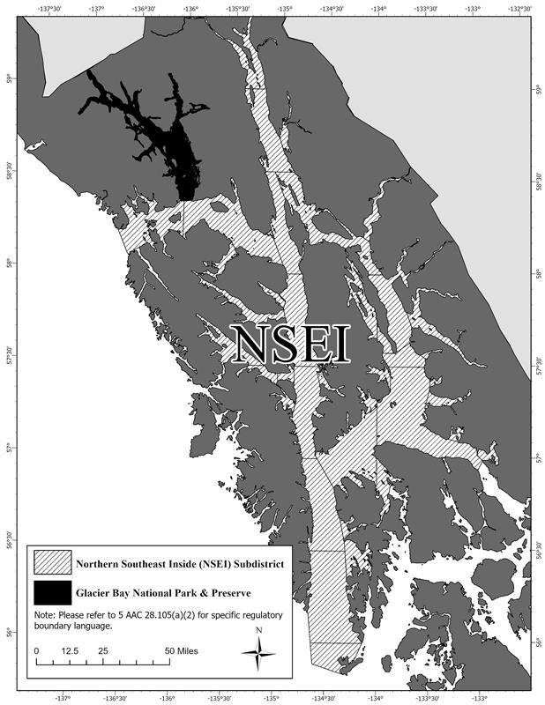
Figure 1.–Northern Southeast Inside (NSEI) Subdistrict including restricted waters of Glacier Bay National Park and Preserve.
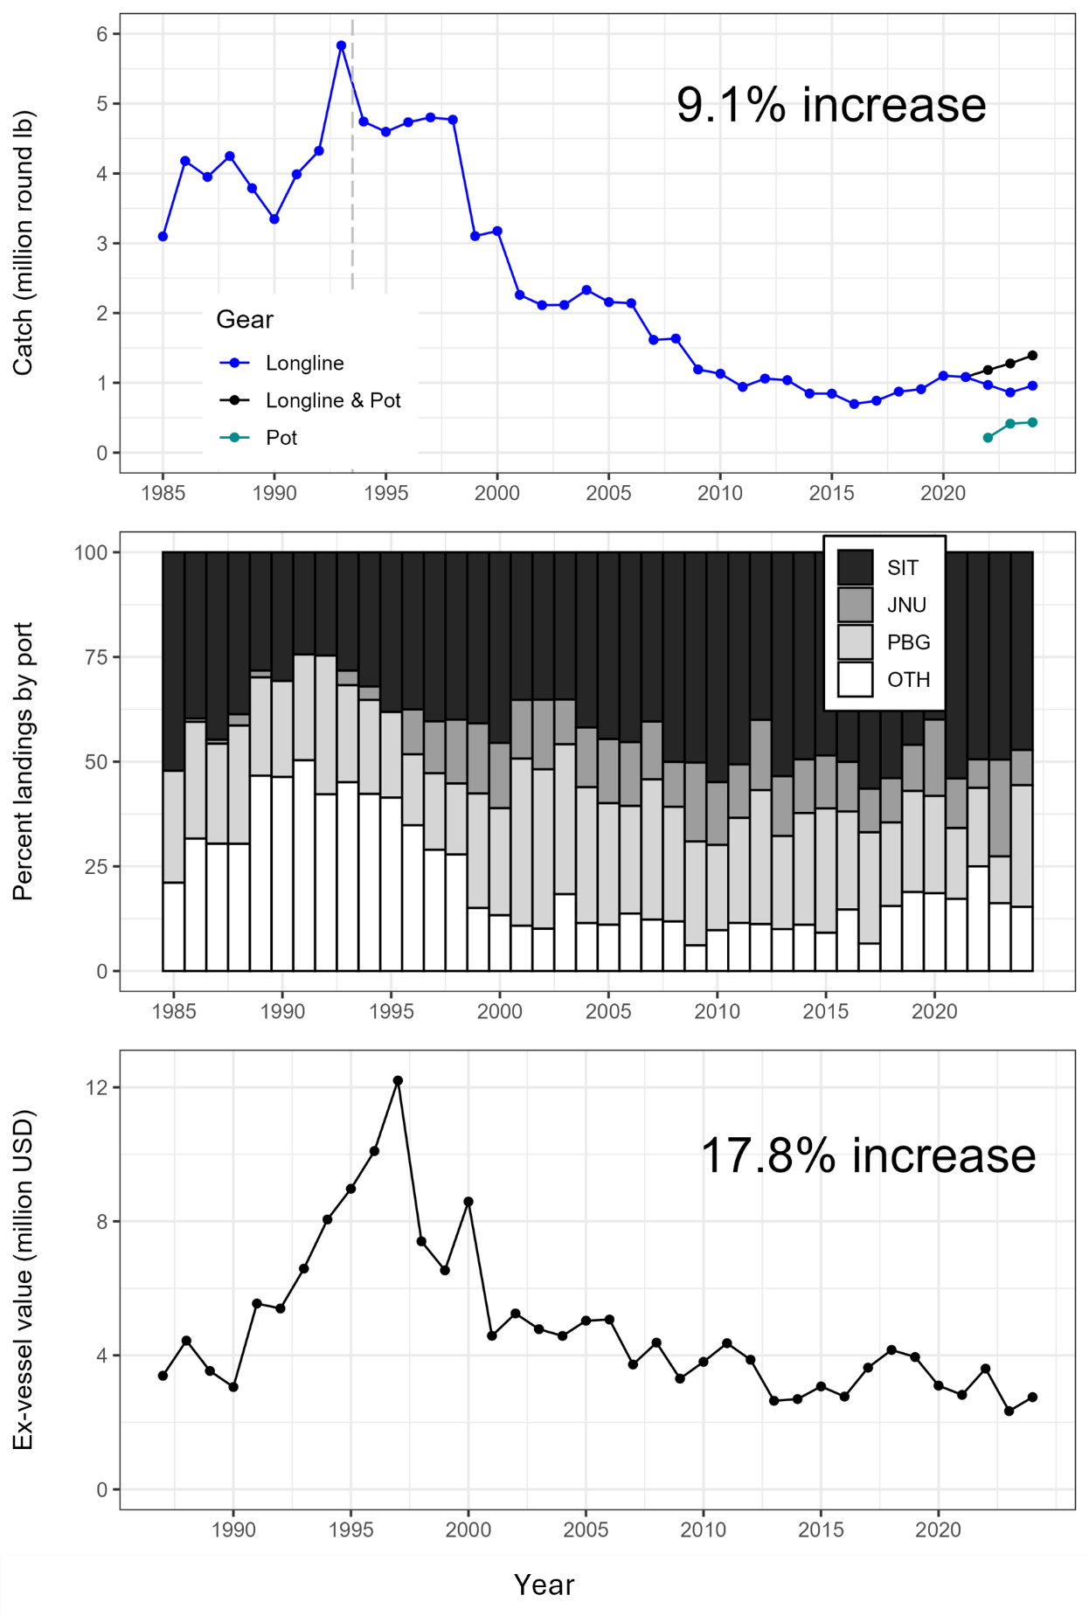
Figure 2.–Catch, landings by port, and exvessel value for Northern Southeast Inside (NSEI) Subdistrict commercial sablefish 1985–2024.
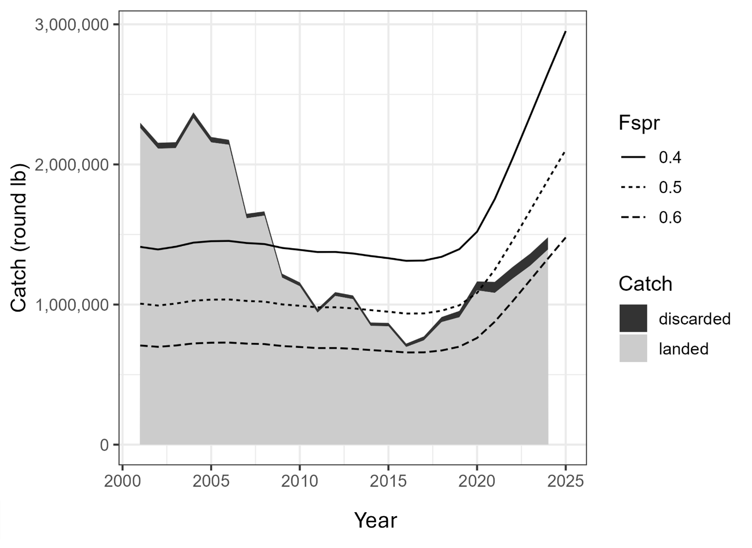
Figure 3.–Estimated catch in the Northern Southeast Inside (NSEI) Subdistrict fishery from 2000–2024 and the relationship to F₄₀, F₅₀ and F₆₀ (F_{spr}), the fishing mortality that results in a spawning potential ratio (SPR) of 40, 50 and 60% of the population’s virgin state, respectively, in the model.

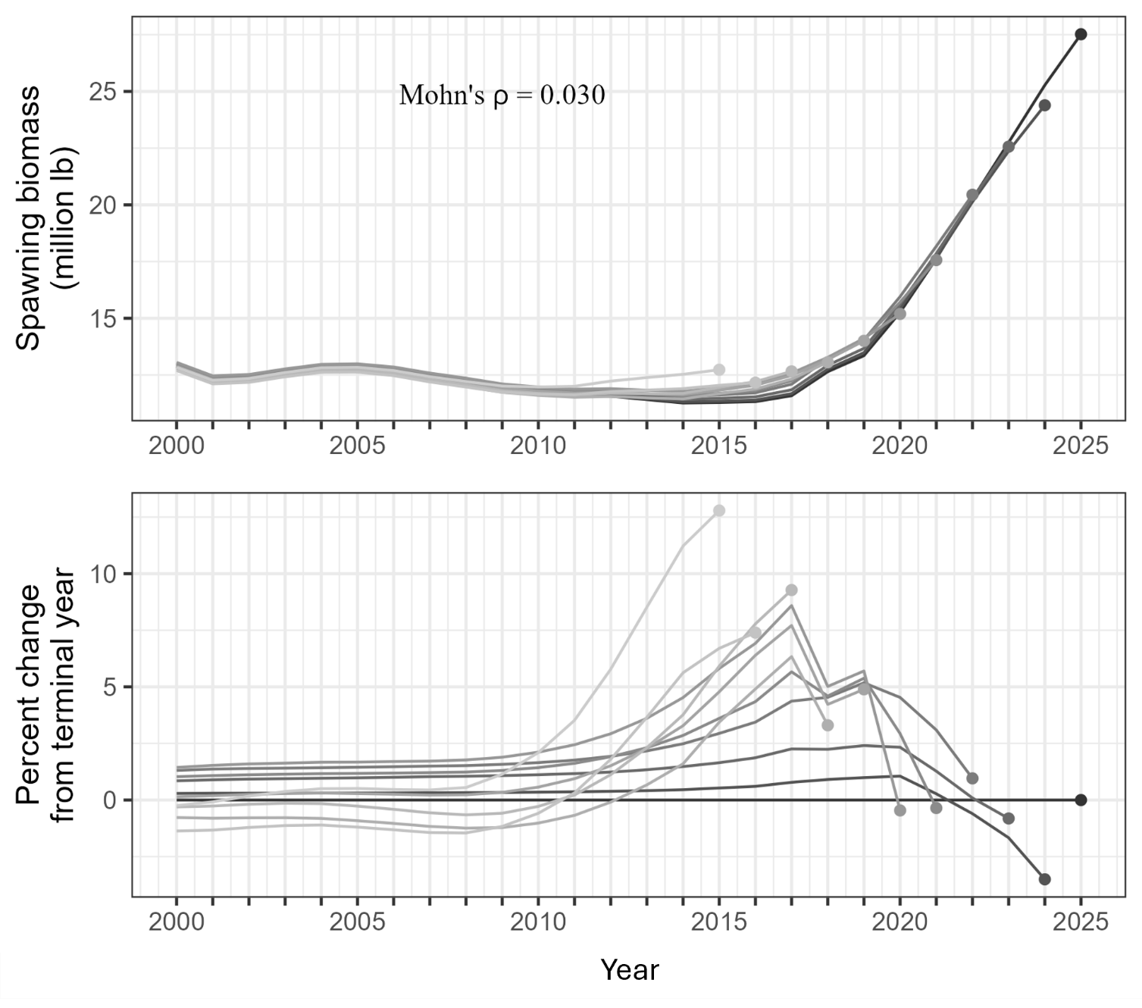
Figure 4.–Mohn’s ρ and retrospective peels of estimated sablefish spawning biomass.

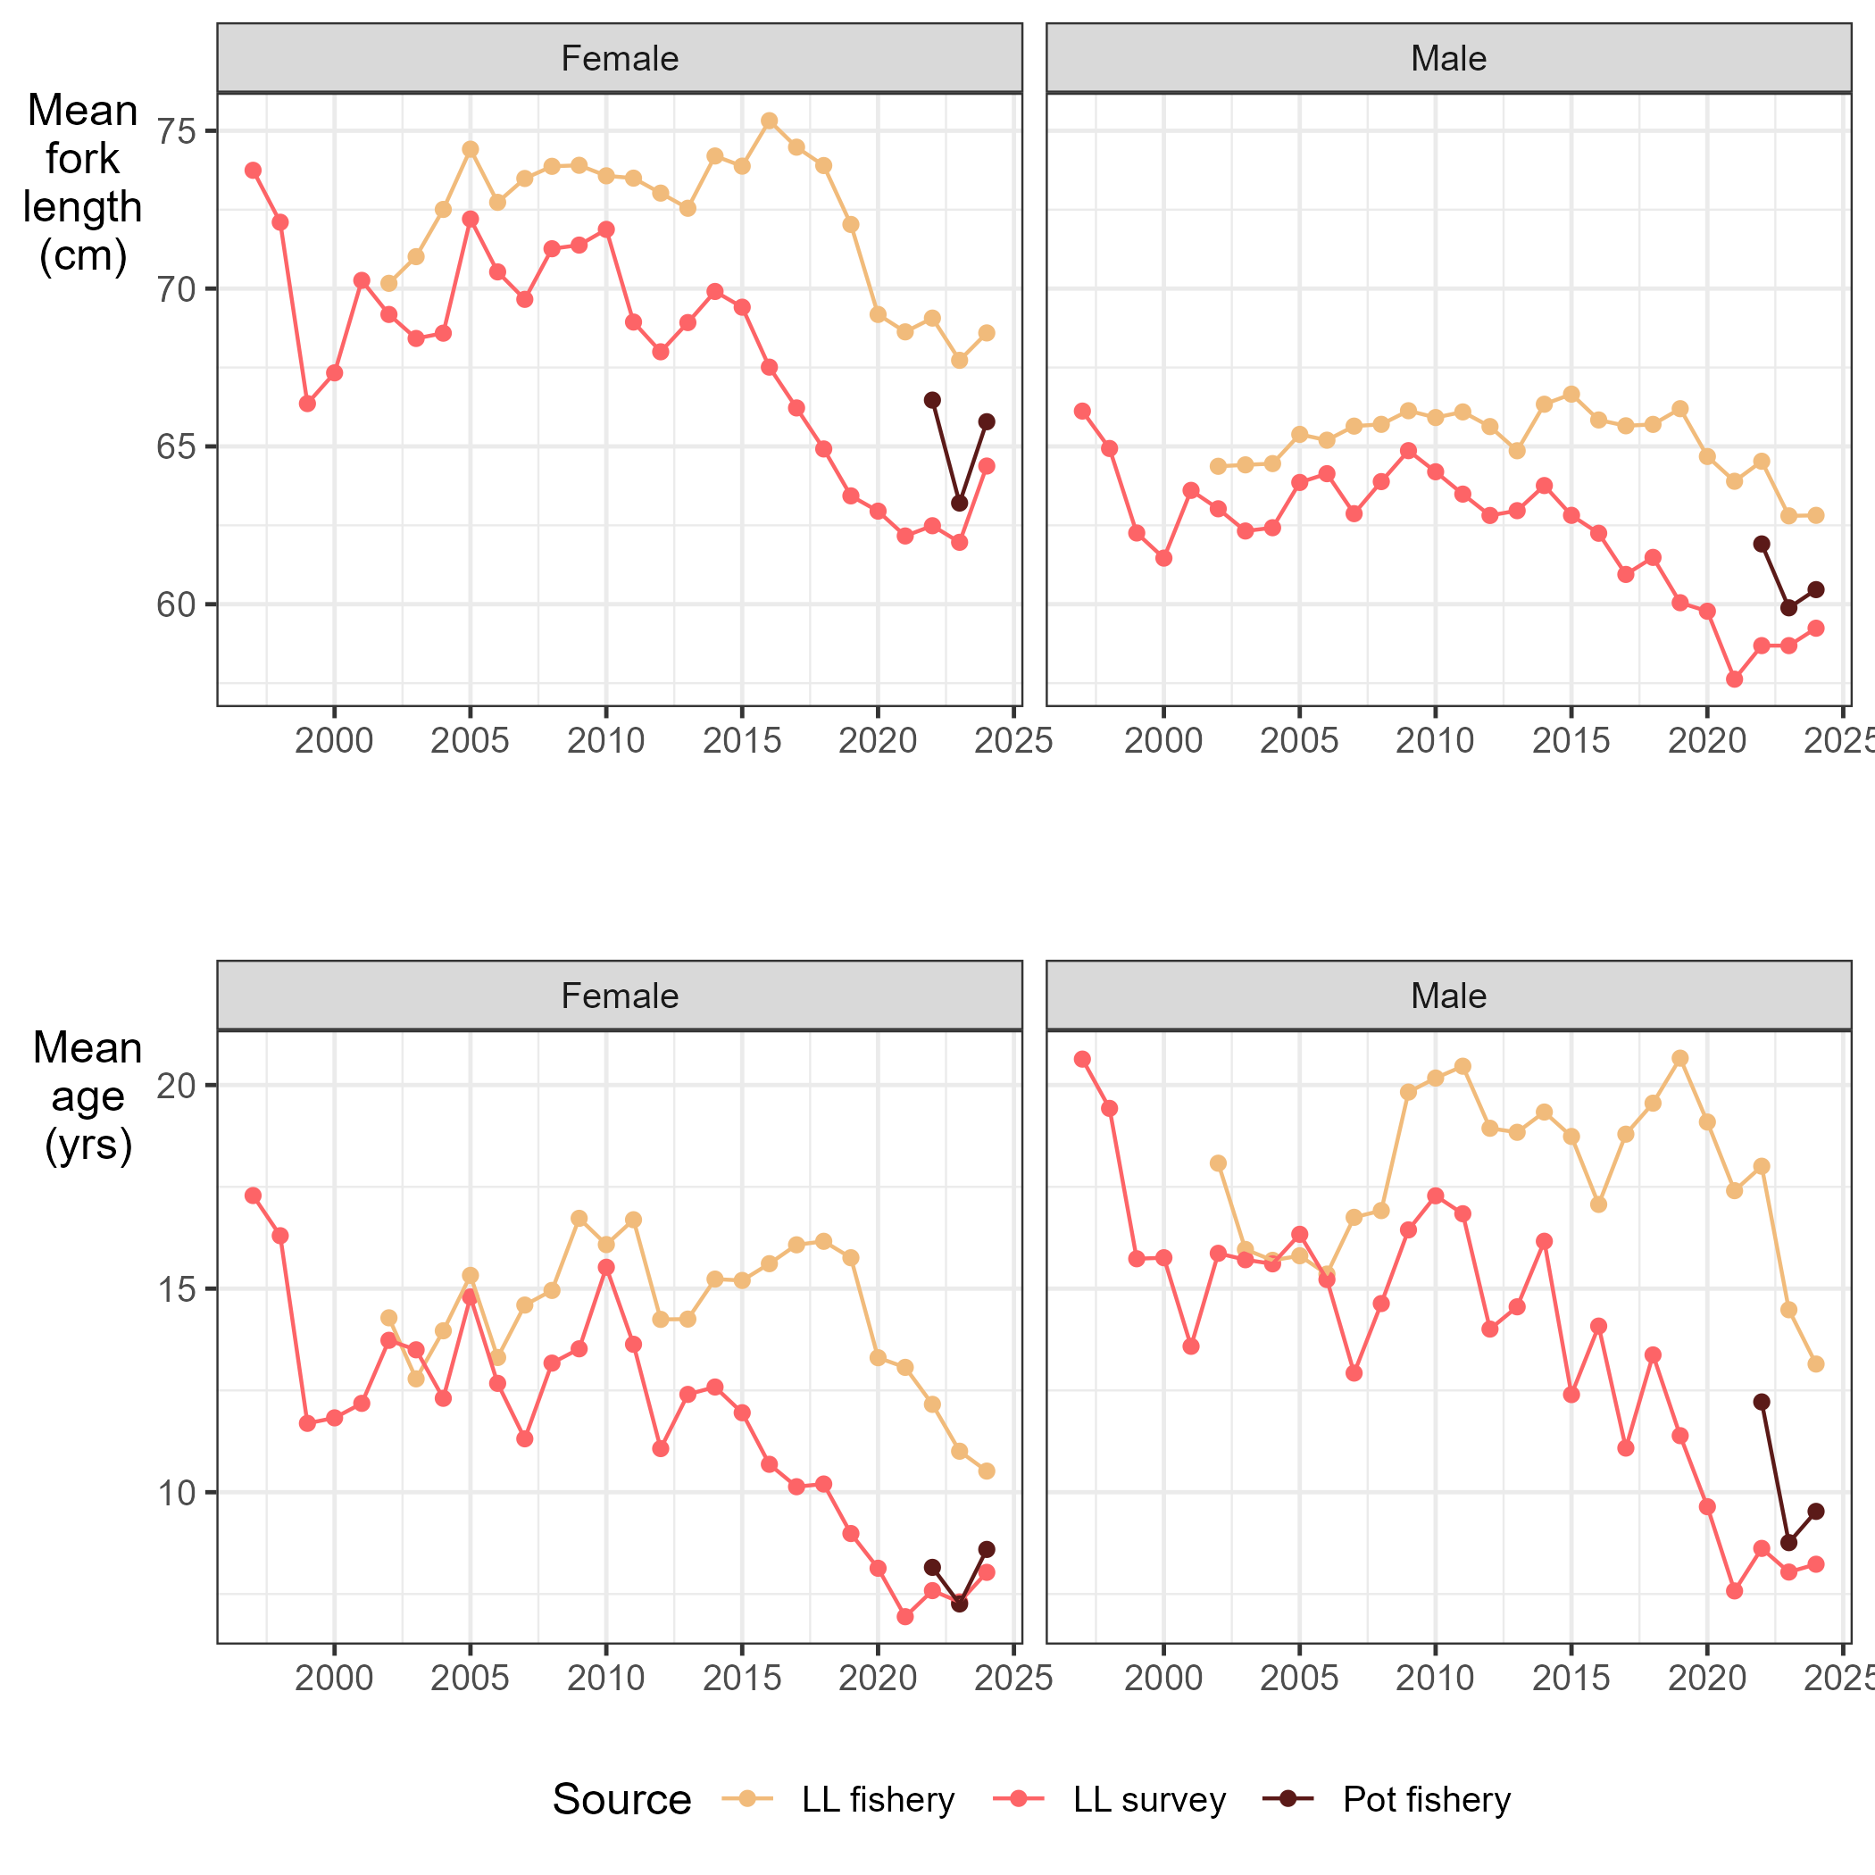
Figure 5.–Comparison of the mean length and age in the longline (LL) and pot fisheries and longline survey since 1997 for male and female sablefish in the Northern Southeast Inside (NSEI) Subdistrict. The pot fishery is only included for 2022-2024 when pot gear became a legal gear type in the fishery. The fishery data come from retained catch.

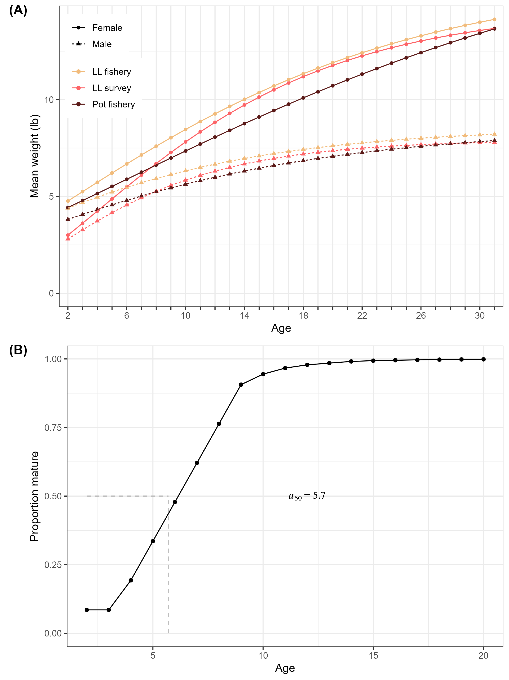
Figure 6.– Biological inputs to the statistical catch-at-age model, including: (A) von Bertalanffy growth model predictions of weight-at-age (kg) by sex from the longline fishery (gold), pot fishery (brown), and ADF&G longline survey (red), and (B) proportion mature at age for females estimated from the longline survey with the age at 50% maturity (a₅₀ = 5.7 yr) indicated by the dashed grey line.
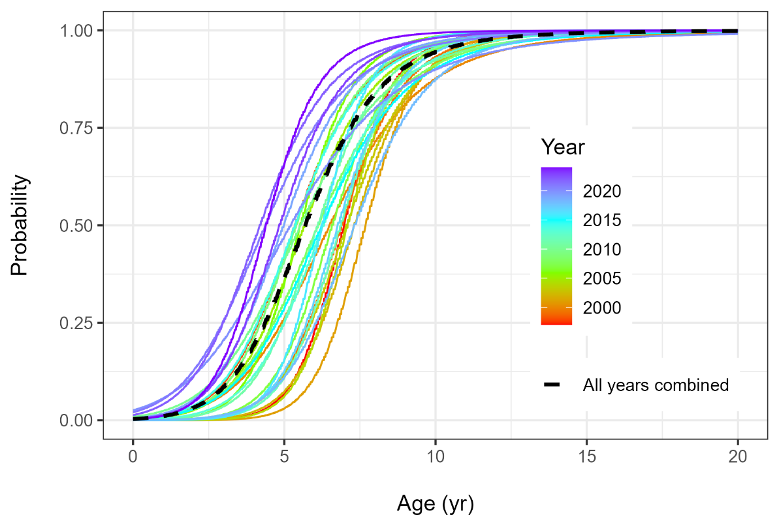
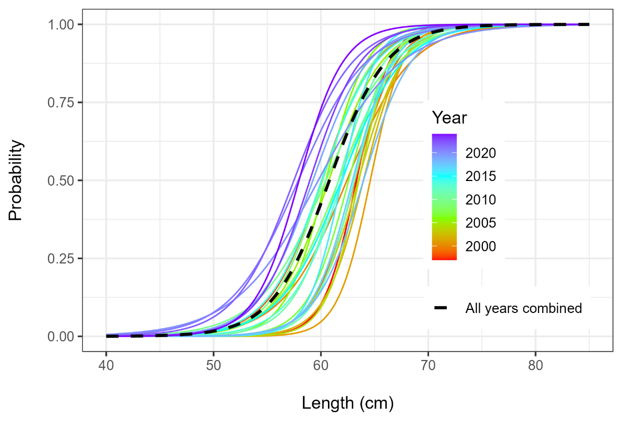

Figure 7.–Changes in maturity-at-age (top panel) and -length (bottom panel) over time in the Northern Southeast Inside (NSEI) Subdistrict sablefish population, showing a general trend of fish maturing at younger ages and smaller sizes.
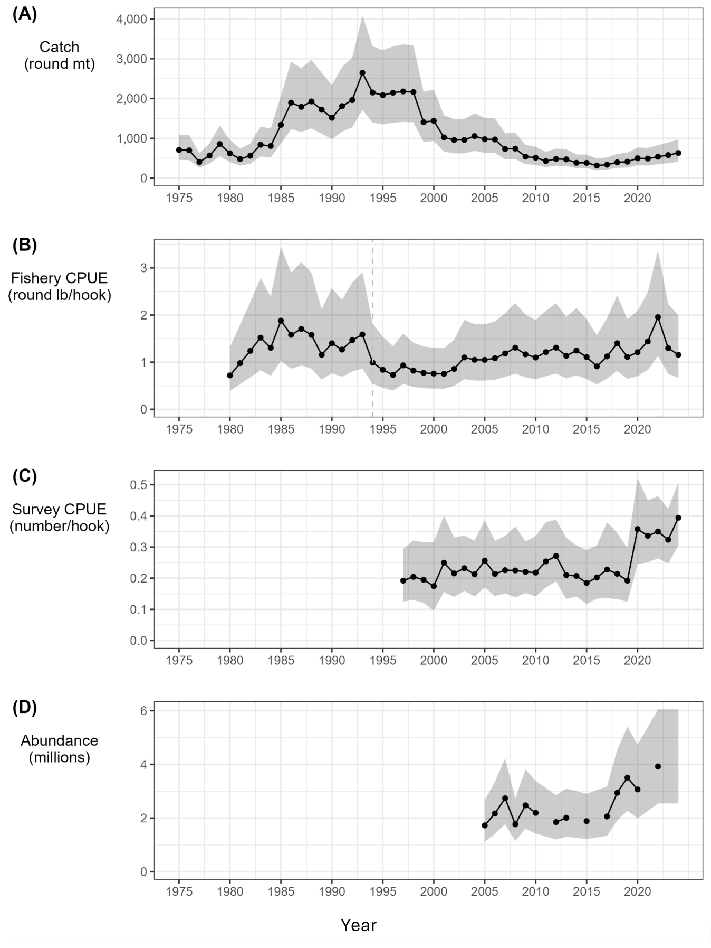
Figure 8.–Indices of catch and abundance with the assumed error distribution, including: (A) harvest (round mt); (B) fishery catch per unit effort in round lb per hook; (C) survey catch per unit effort in number of fish per hook; and (D) mark–recapture abundance estimates in millions. The dashed vertical line in 1994 marks the transition to the Equal Quota Share program.
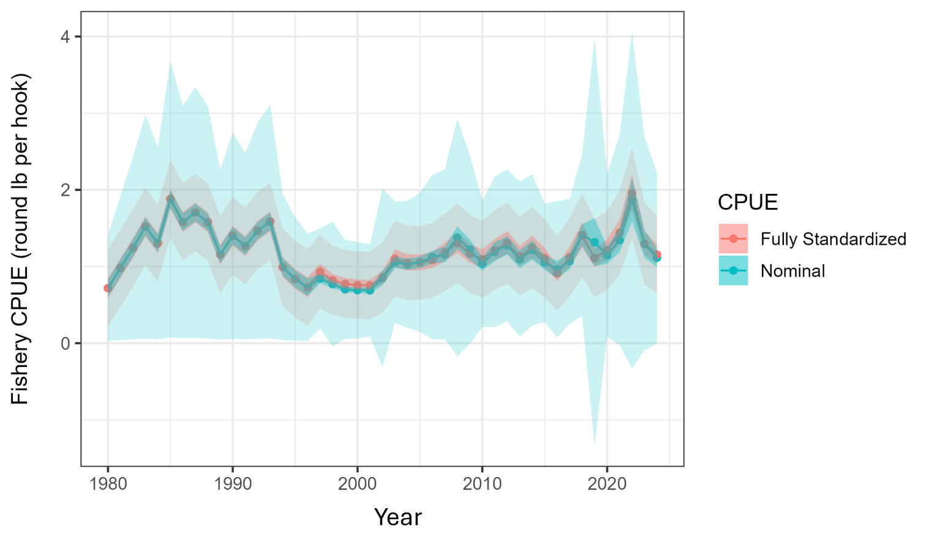
Figure 9.–Nominal (blue) versus fully standardized (red) catch per unit effort (CPUE) in the NSEI Subdistrict longline sablefish fishery in round lb per hook. The fully standardized CPUE values were used in this assessment.

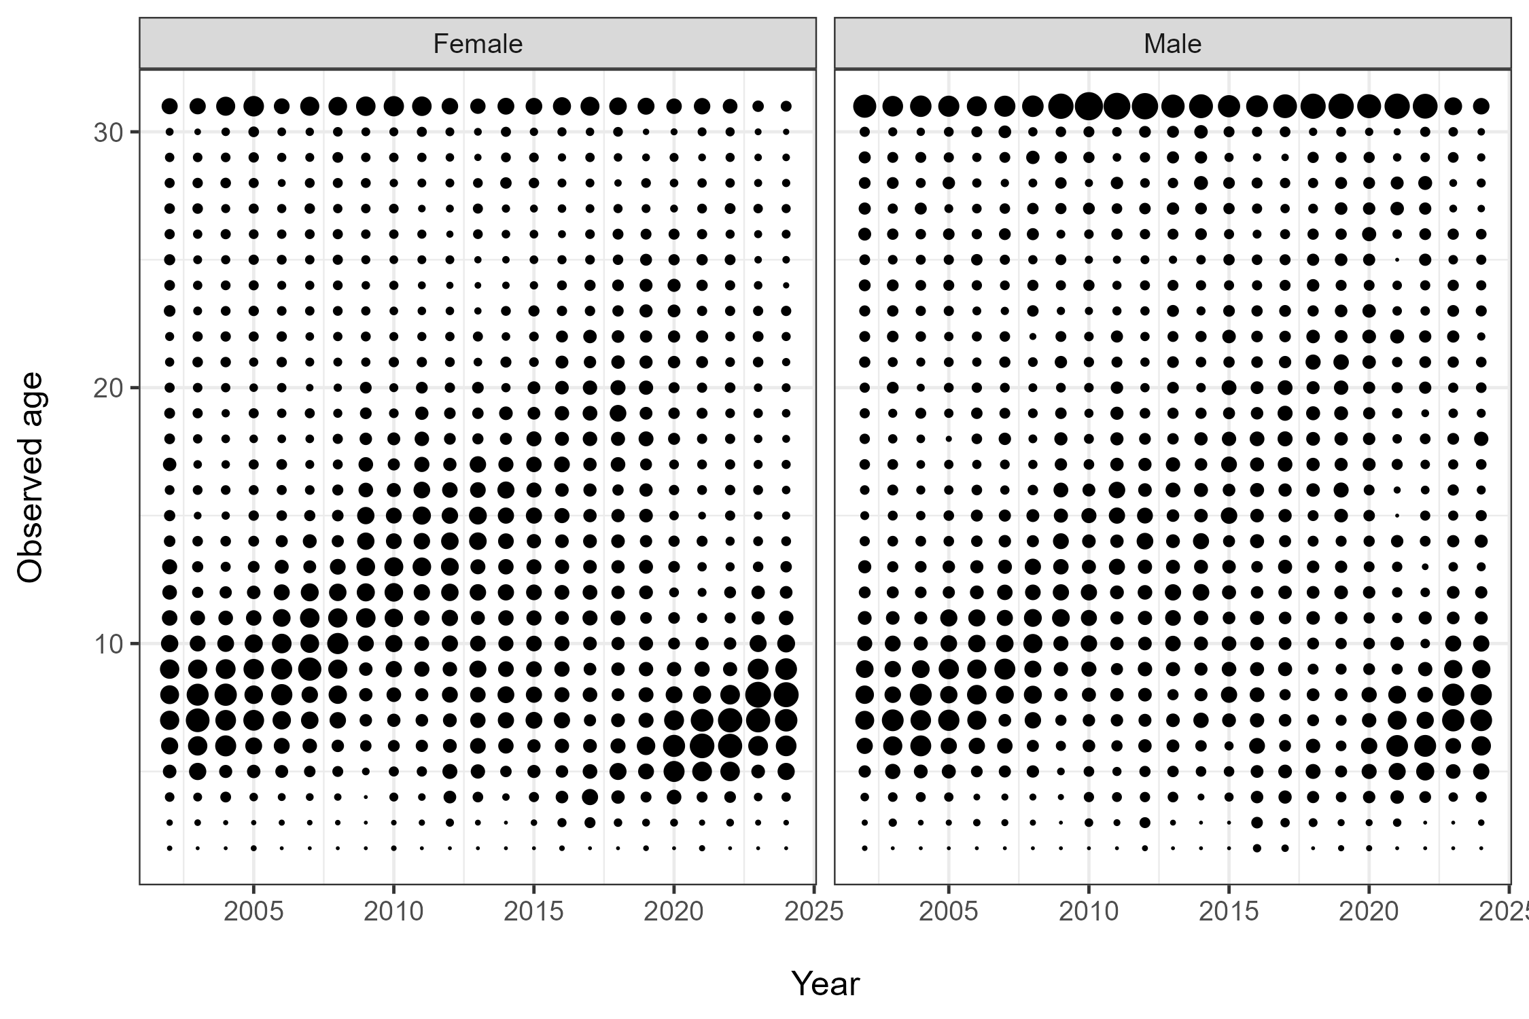
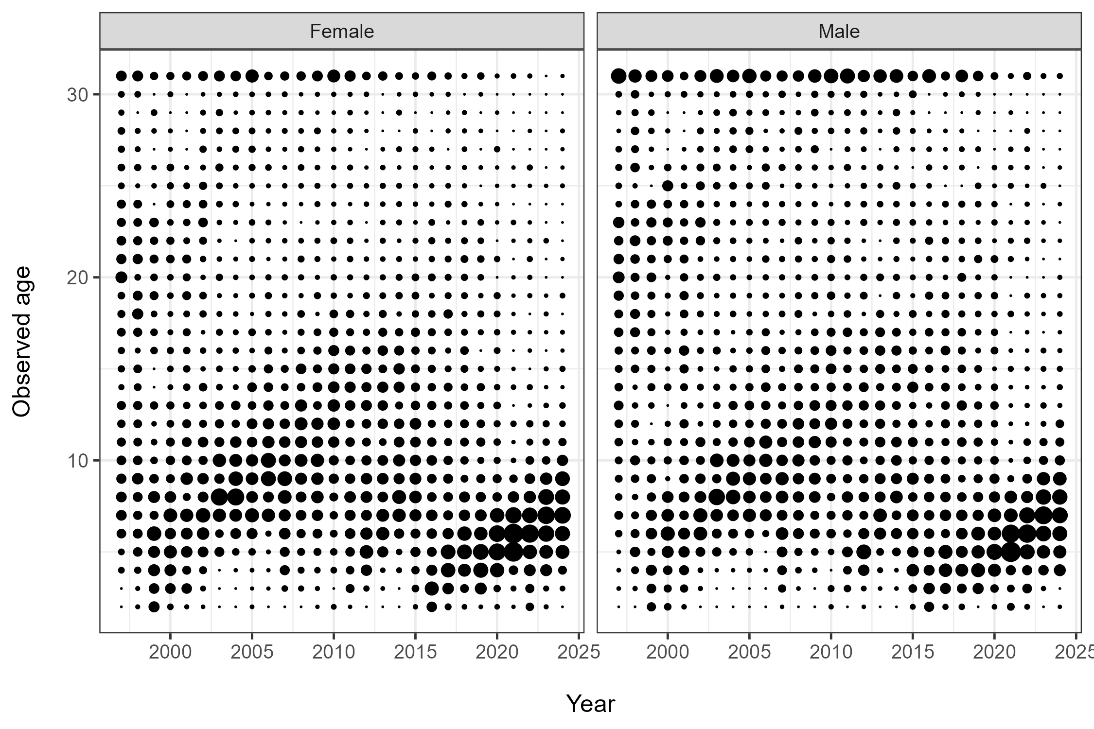
Figure 10.–Fishery age compositions by sex for the Northern Southeast Inside (NSEI) Subdistrict longline fishery (2002–2024, top row) and ADFG longline survey (1997–2024, bottom row).

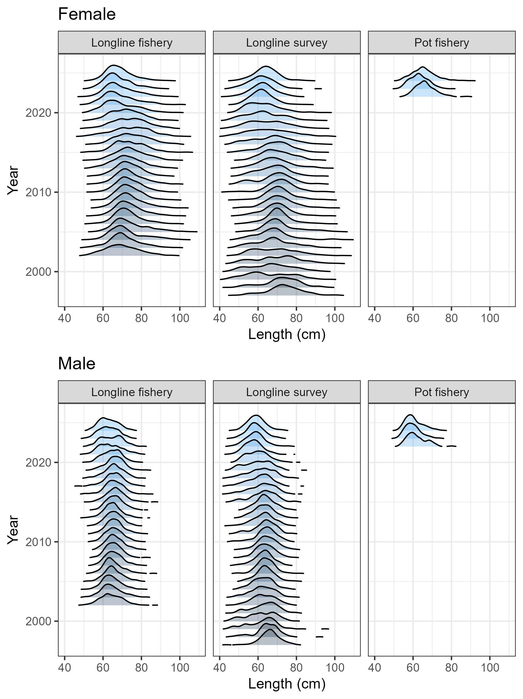
Figure 11.–Longline fishery, pot fishery, and survey length distributions by sex from 1997–2024.
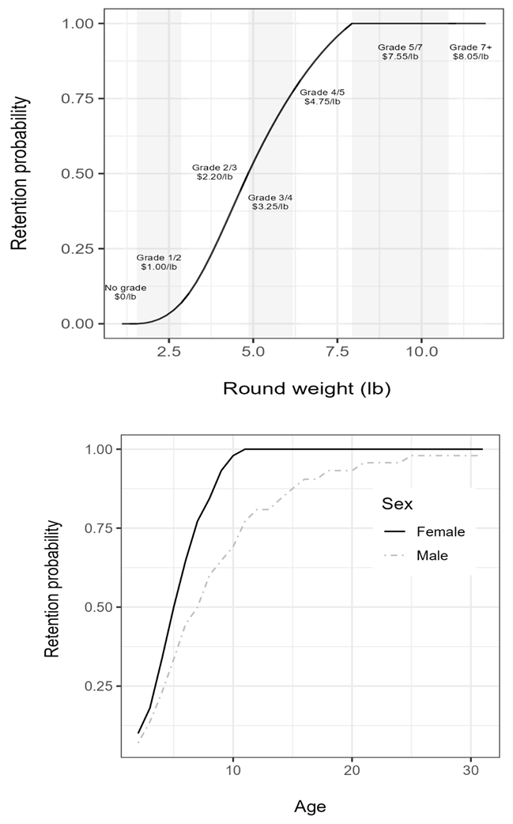
Figure 12.–Probability of retaining a fish as a function of weight (top), sex, and age (bottom).

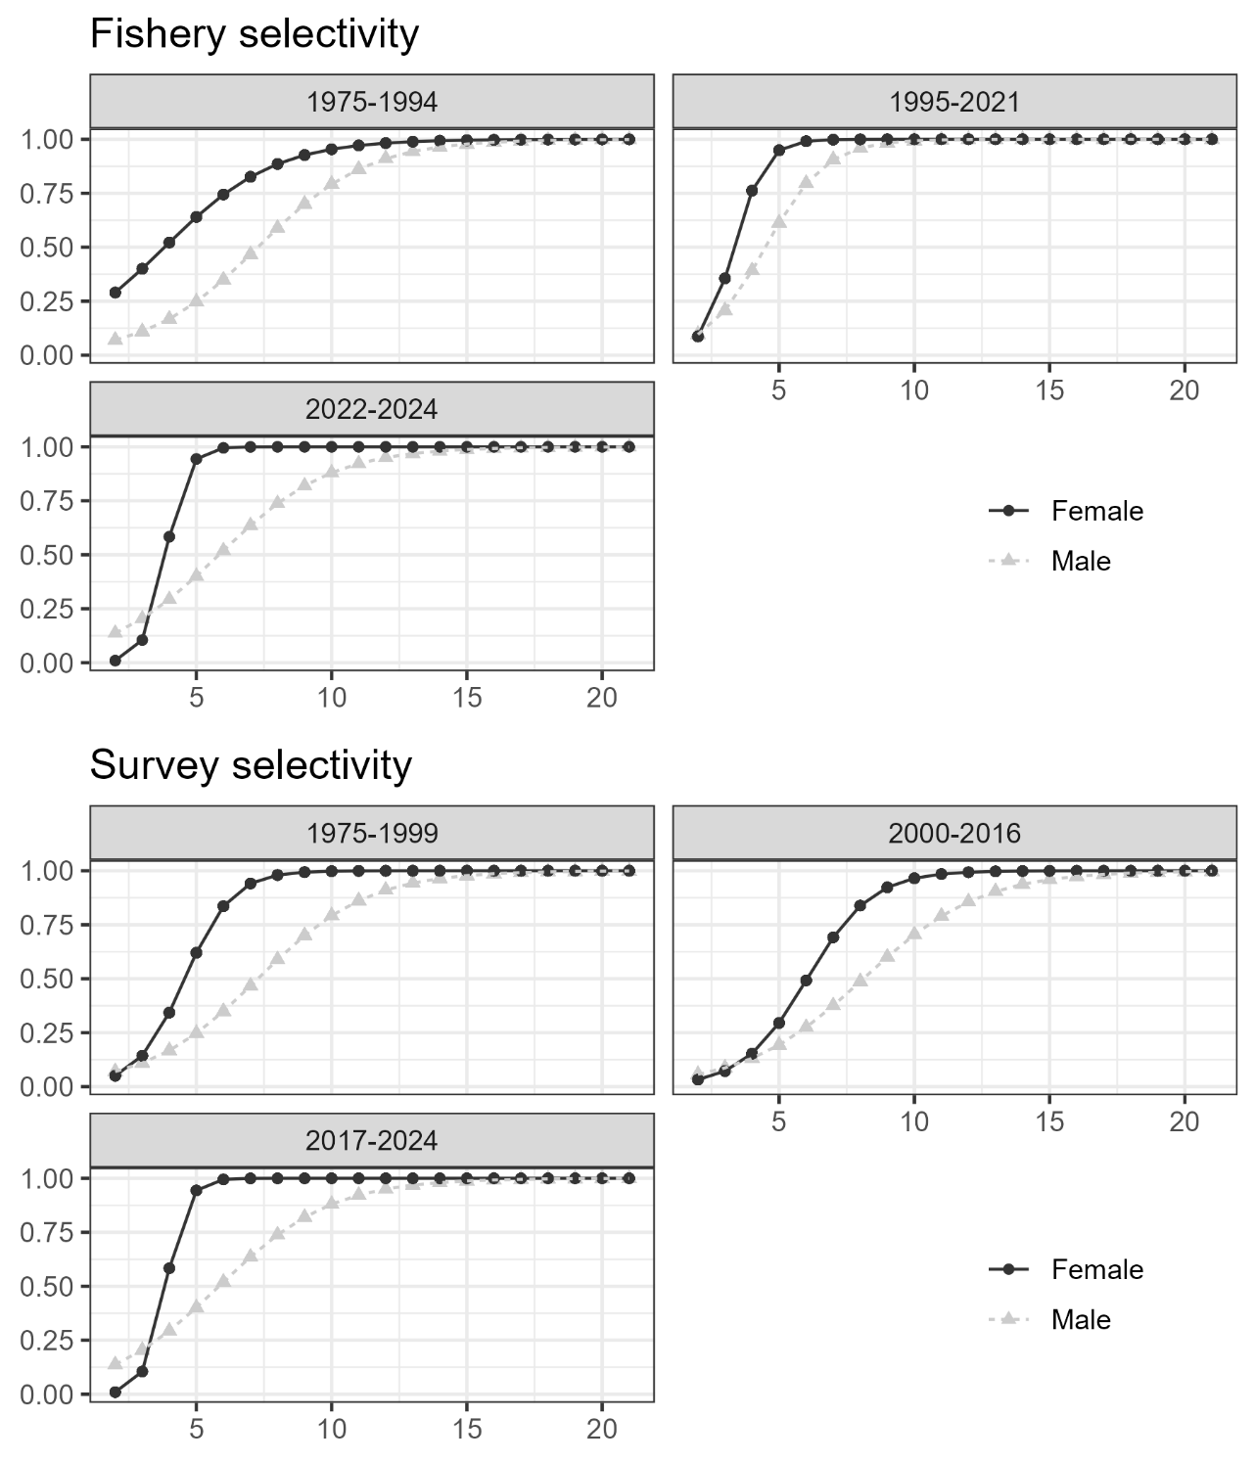
Figure 13.–Fishery selectivity (top): fixed age-based selectivity curves for the fishery before the Equal Quota Share (EQS) program started in 1994 (pre-EQS), the fishery since the implementation of EQS while it was solely longline gear (1995–2021), the fishery since it became a mixed gear fishery (2022-present). Survey selectivity (bottom): ADF&G longline survey for females (black) and males (grey) before the standardization of the survey in 2000, and for the time blocks of 2000–2016 and 2017–2024.

Figure 14.–Probability of retaining a fish as a function of weight (top), sex, and age (bottom).
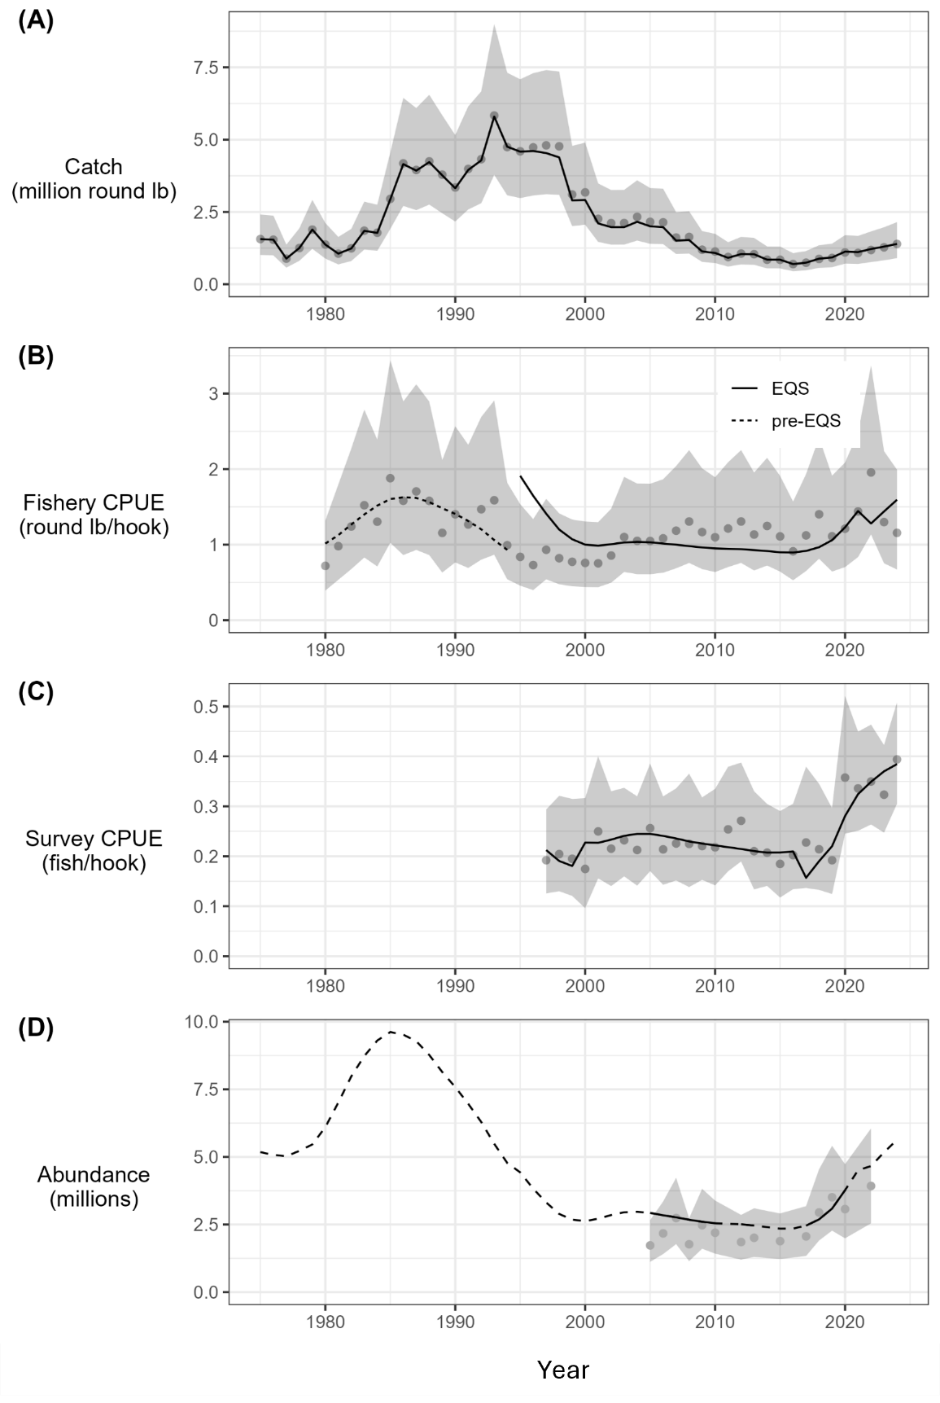
Figure 15.– Fits to indices of catch and abundance with the assumed error distribution shown as shaded grey polygons. Input data are shown as grey points and model fits are shown in black. Indices include: (A) harvest (million round lb); (B) fishery CPUE in round lb per hook with separate selectivity and catchability time periods before and after the implementation of the EQS program in 1994; (C) survey CPUE in number of fish per hook; and (D) mark–recapture abundance estimates in millions. Solid and dashed lines in (D) reflect years for which data were and were not available, respectively.
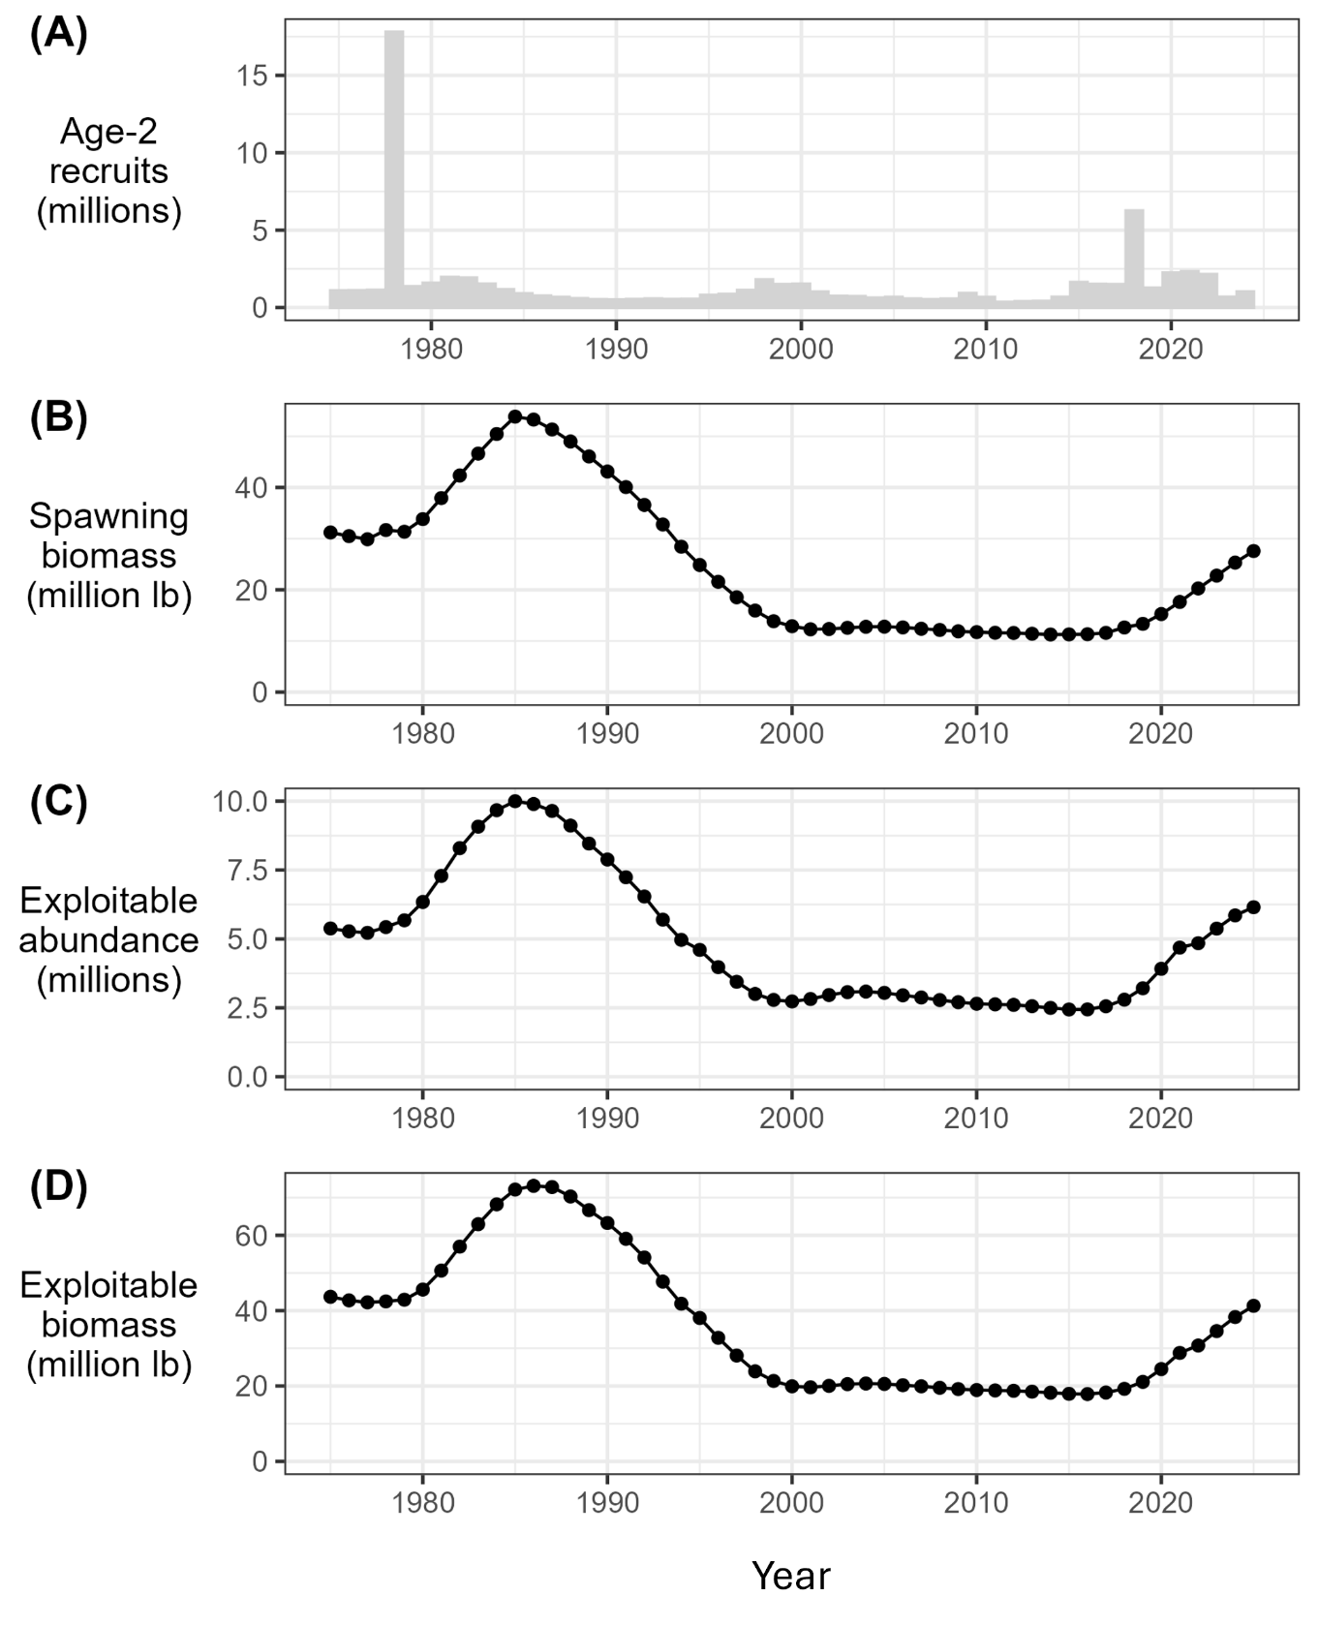
Figure 16.–Model predictions of (A) age-2 recruitment (millions); (B) female spawning stock biomass (million pounds); (C) exploitable abundance (millions); and (D) exploitable biomass (million pounds).

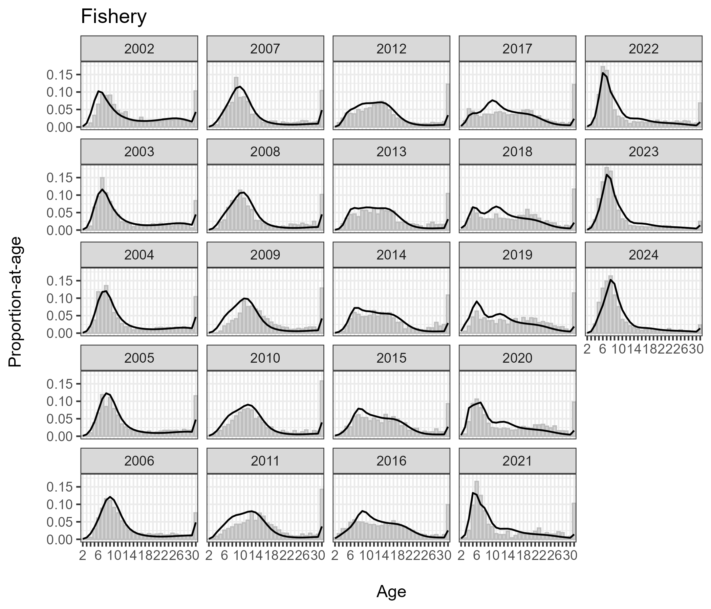
Figure 17.–Fits to fishery age compositions, 2002–2024. Observed and predicted proportions-at-age shown as grey bars and black lines, respectively.

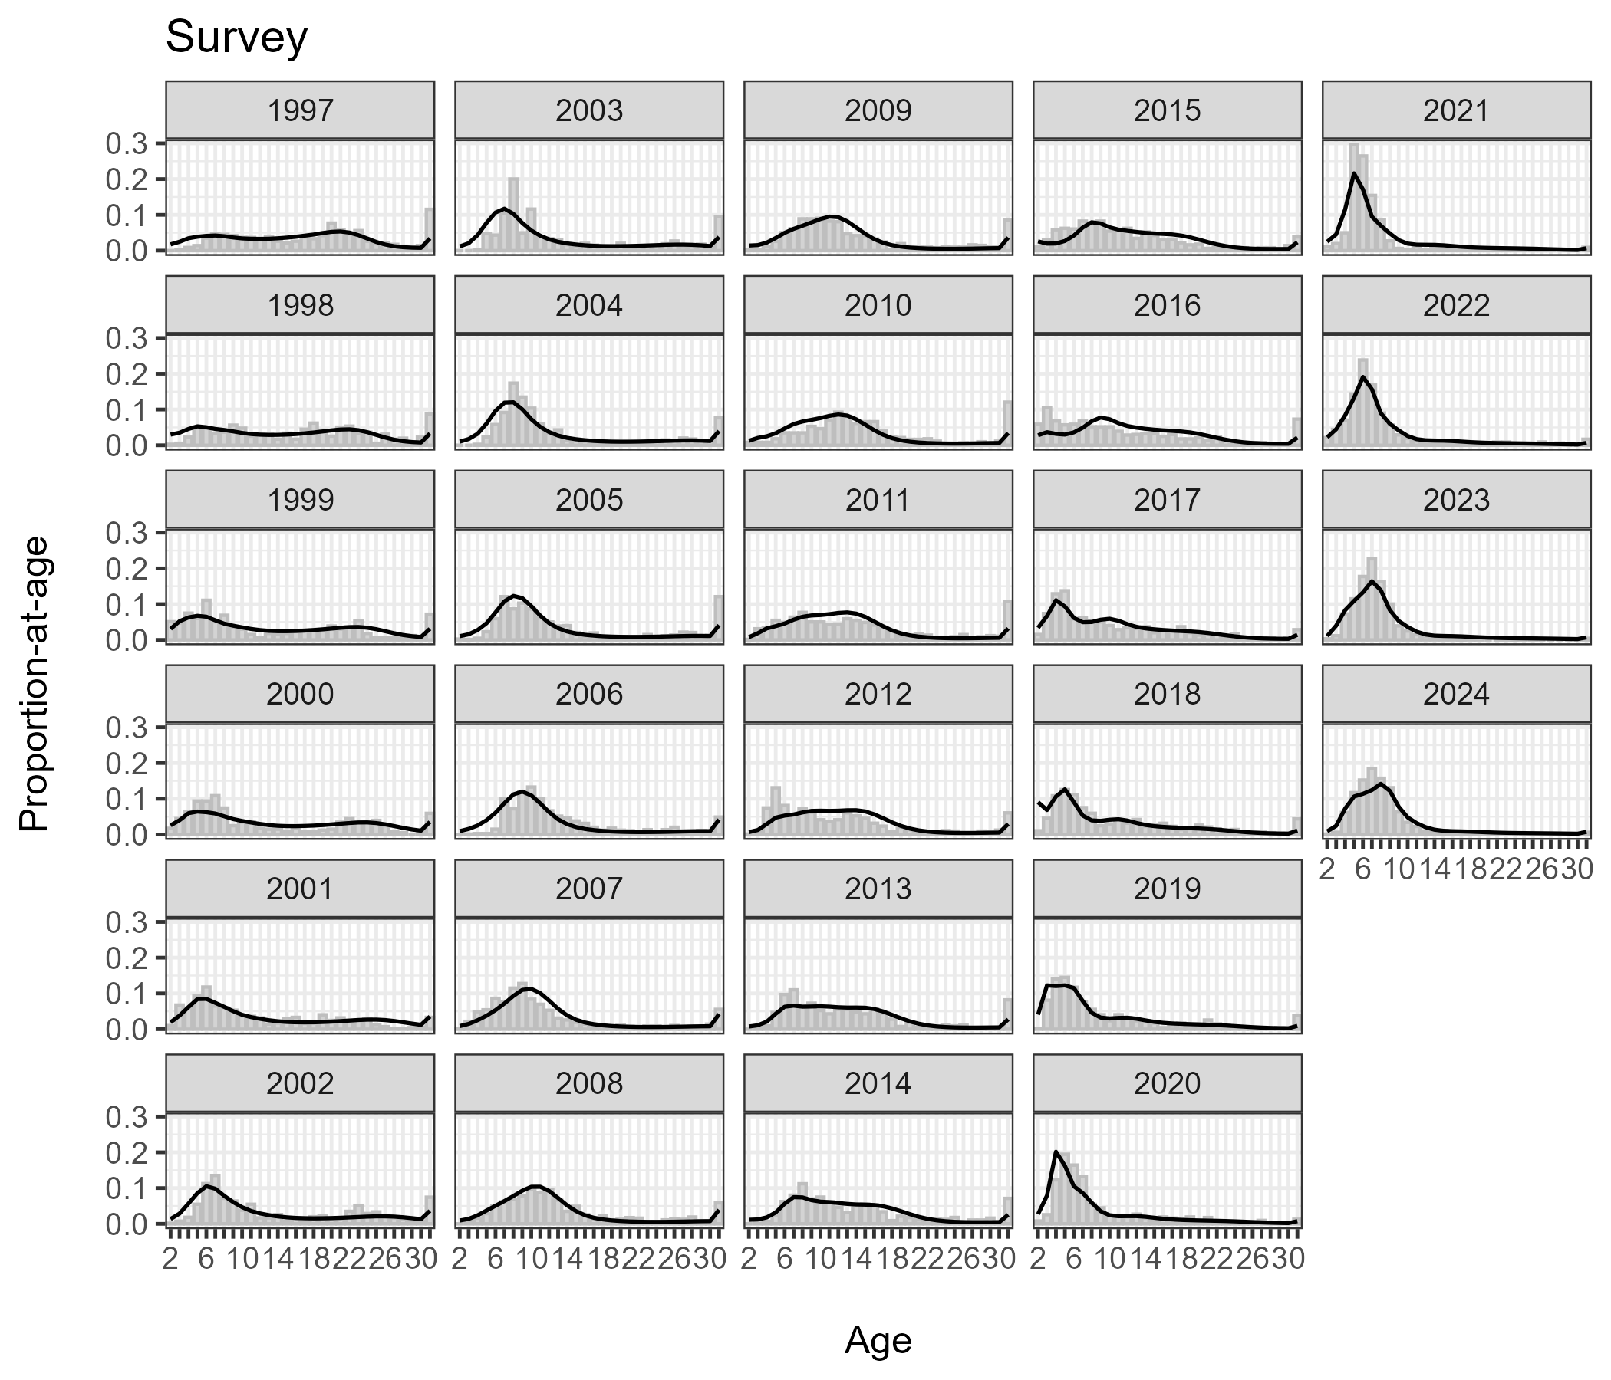
Figure 18.–Fits to survey age compositions, 1997–2024. Observed and predicted proportions-at-age shown as grey bars and black lines, respectively.

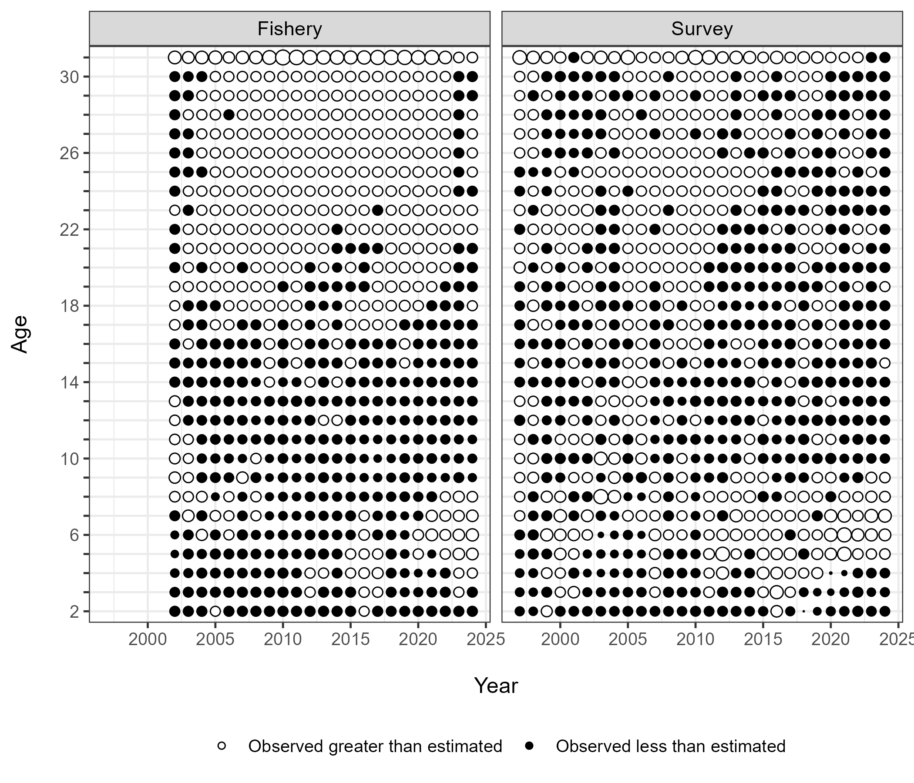
Figure 19.–Standardized residuals of fits to fishery (2002–2024) and survey (1997–2024) age compositions. Size of residual scales to point size. Black points represent negative residuals (observed < predicted); white points represent positive residuals (observed > predicted).

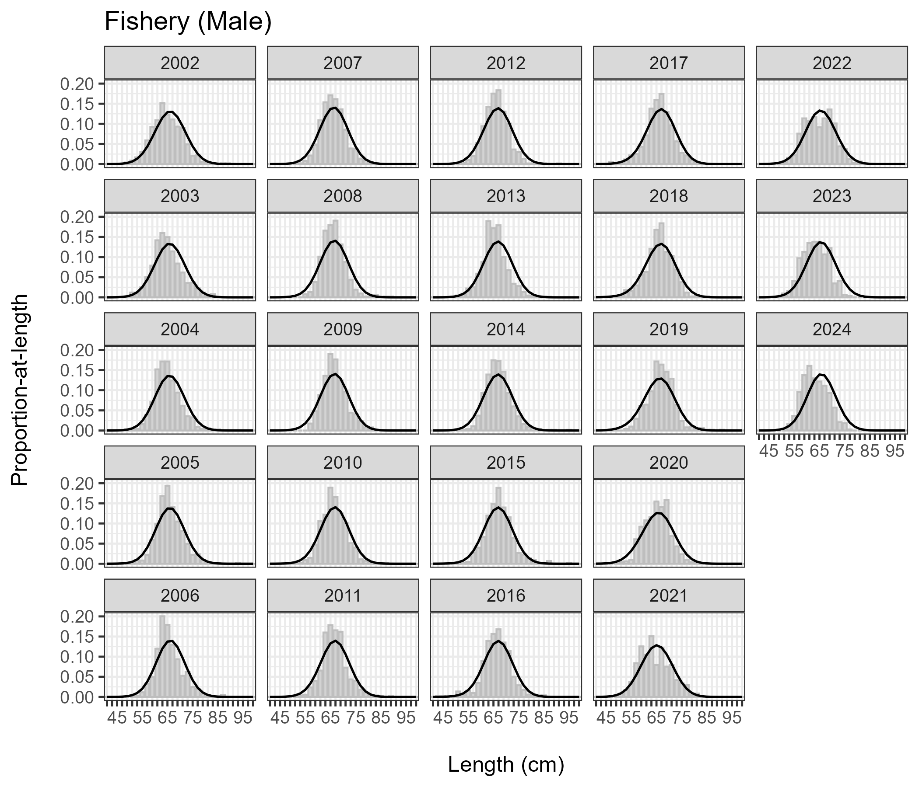
Figure 20.–Fits to male fishery length compositions, 2002–2024. Observed and predicted proportions-at-age shown as grey bars and black lines, respectively.

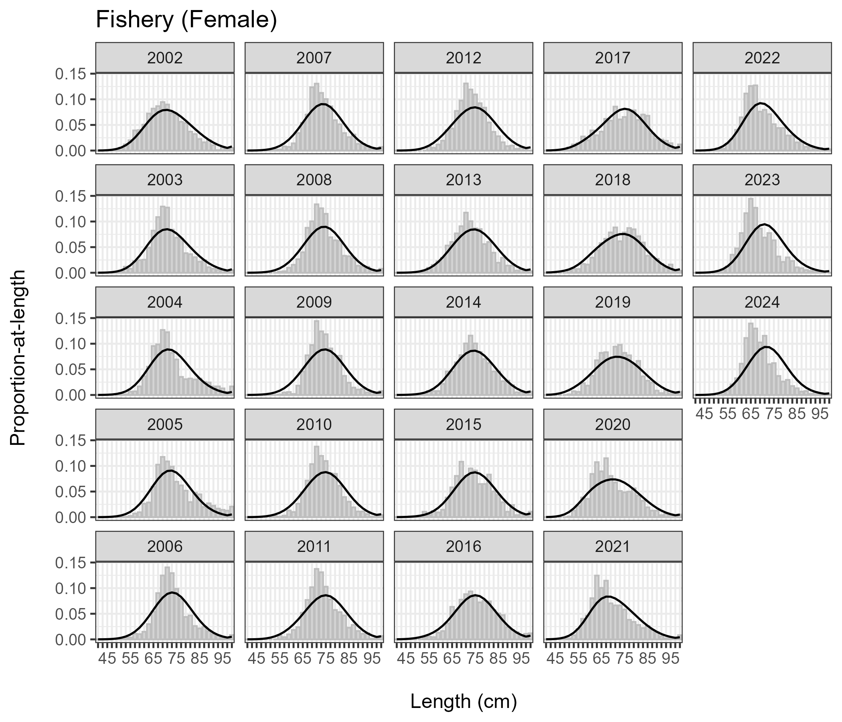
Figure 21.–Fits to female fishery length compositions, 2002–2024. Observed and predicted proportions-at-age shown as grey bars and black lines, respectively.

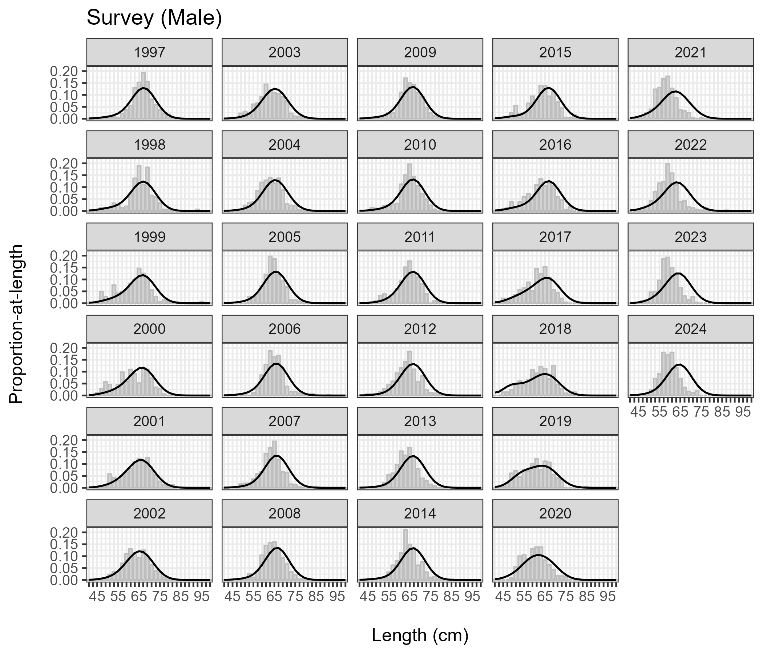
Figure 22.–Fits to male survey length compositions, 1997–2024. Observed and predicted proportions-at-age shown as grey bars and black lines, respectively.

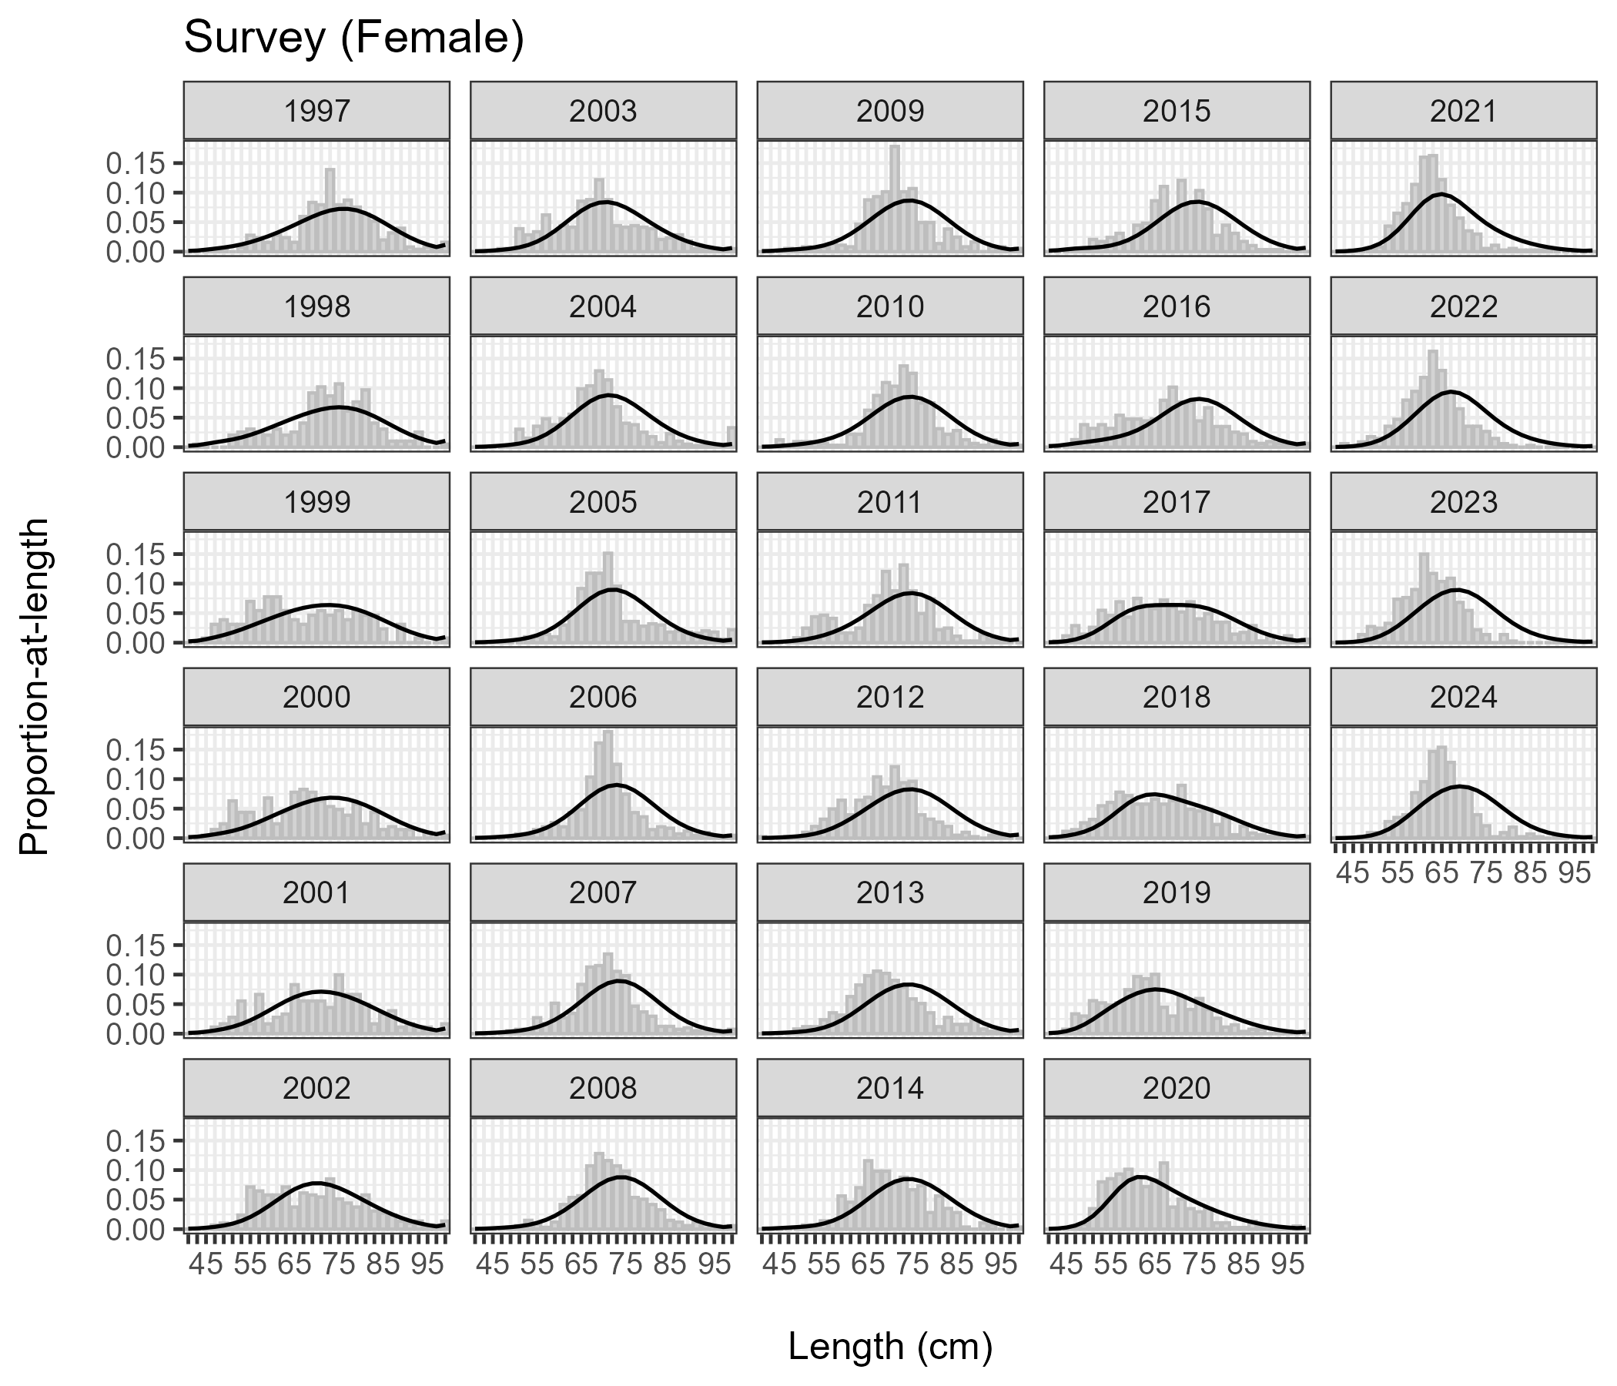
Figure 23.–Fits to female survey length compositions, 1997–2024. Observed and predicted proportions-at-age shown as grey bars and black lines, respectively.

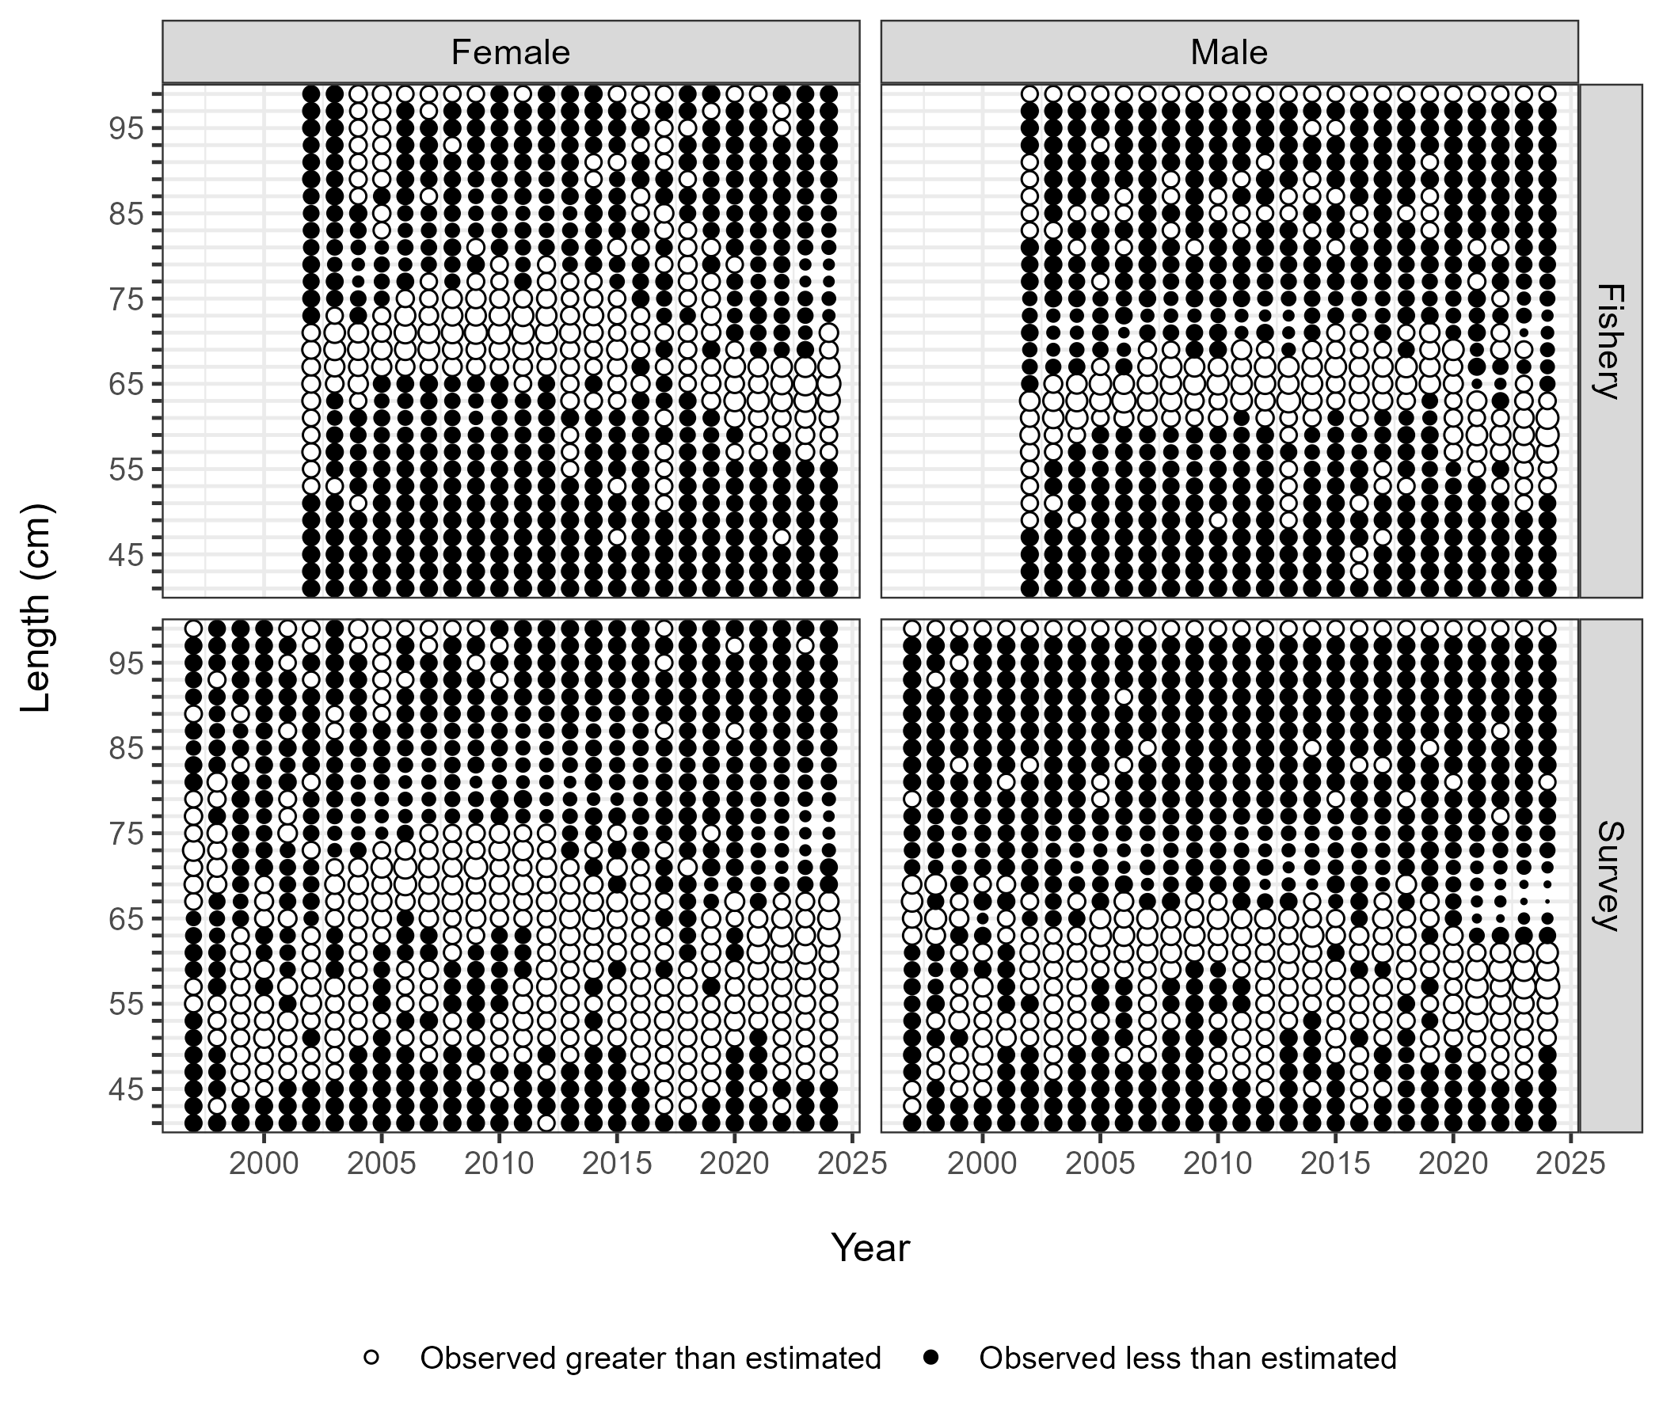
Figure 24.–Standardized residuals of fits to fishery (2002–2024) and survey (1997–2024) length compositions for males and females. Size of residual scales to point size. Black points represent negative residuals (observed < predicted); white points represent positive residuals (observed > predicted).

.

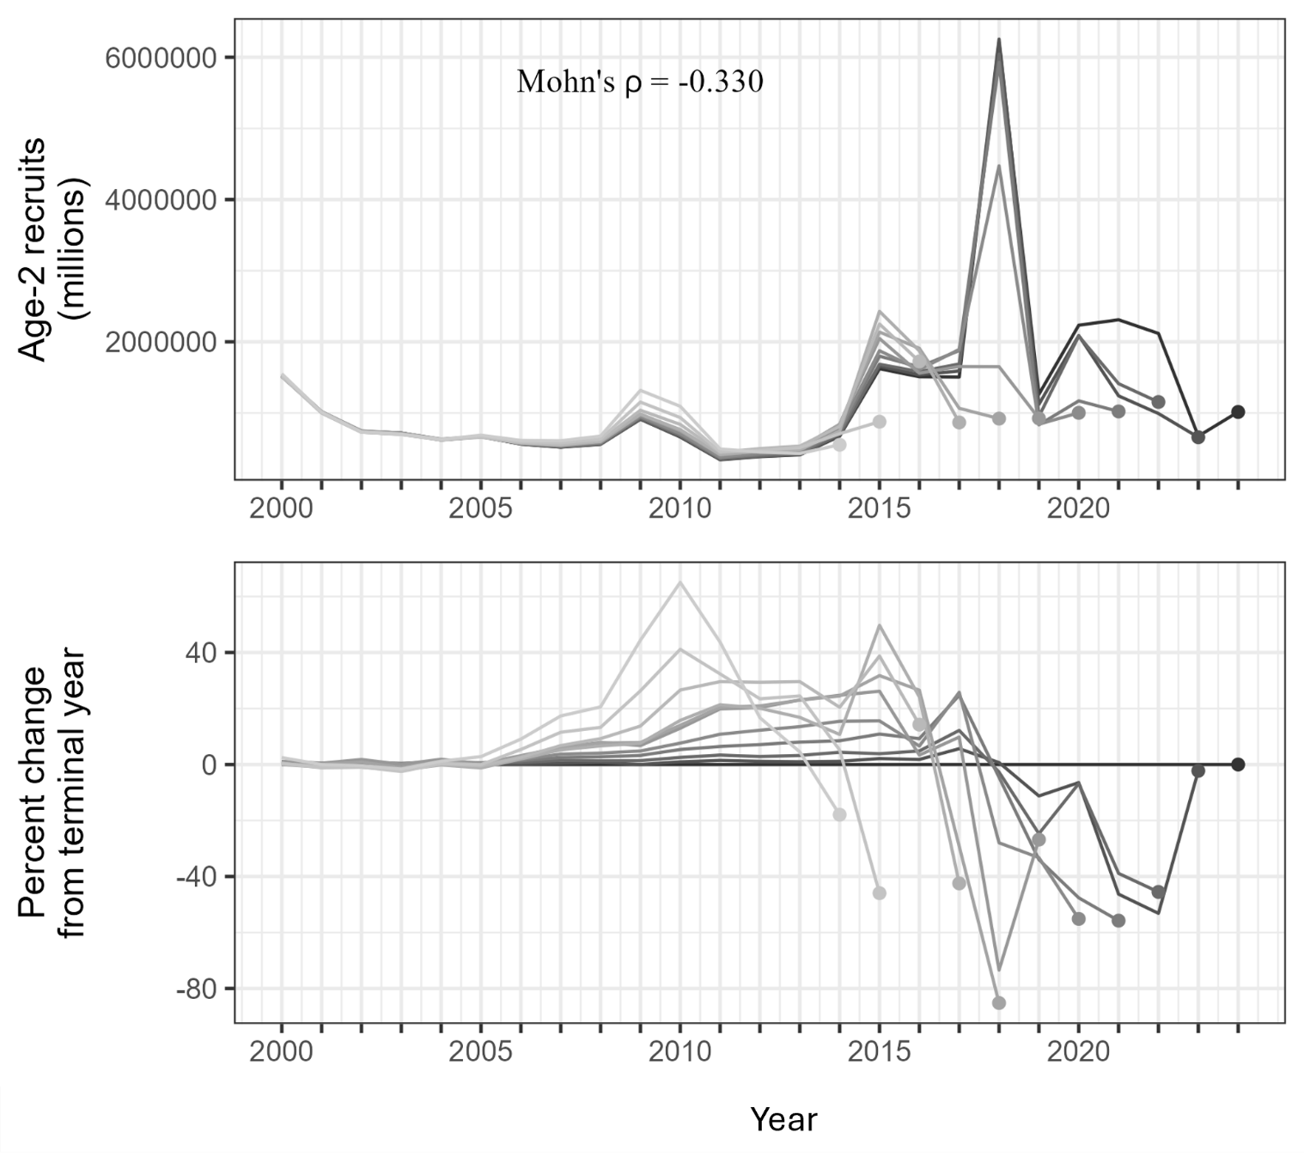
Figure 25.–Mohn’s ρ and retrospective peels of estimated sablefish recruitment.

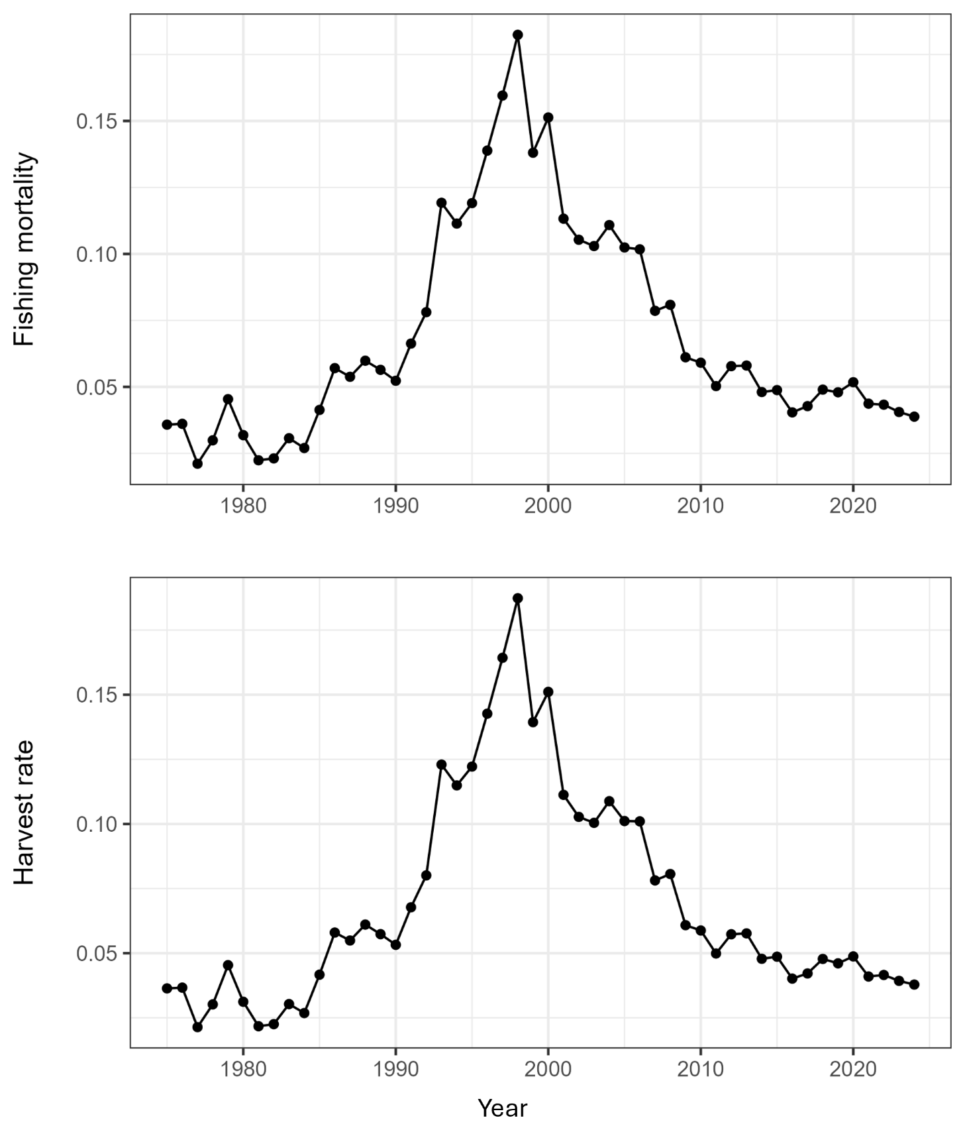
Figure 26.–Model-estimated fishing mortality rate (top) and realized harvest rate (bottom), defined as the ratio of total predicted catch to exploitable biomass. Total predicted catch is the sum of landed catch and discarded biomass assumed to die post-release.

APPENDIX A: MODEL PARAMETERS, DEFINITIONS, AND DATA SOURCES

Appendix A1.–Variable definitions for the statistical catch-at-age model, indexing and model dimensions, data and predicted values.
Variable | Definition
w_{a} | Weight-at-age
p_{a} | Proportion mature-at-age
r_{a} | Proportion female-at-age
R | Retention probability
s_{a} | Selectivity-at-age
Ωa′,a | Ageing error matrix (proportion observed at age given the true age a′a′)
Λa,l,k | Age-length key (proportion in length bin given age and sex)
N | Numbers-at-age
C | Landed catch in numbers-at-age
I, $\hat{I}$ | Indices of abundance, $\hat{I}$ are predicted values
P_{a}, ${\hat{P}}_{a}$ | Age compositions, ${\hat{P}}_{a}$ are predicted values
P_{l}, ${\hat{P}}_{l}$ | Length compositions, ${\hat{P}}_{l}$ are predicted values
Y, $\hat{Y}$ | Landed catch biomass, $\hat{Y}$ are predicted values
$$\hat{W}$$ | Estimated mortality from discards (biomass)
λ | Weight for likelihood component
L | Likelihood
ω | Effective sample size for age and length compositions
n | Input sample size for Dirichlet-multinomial likelihood
c | Small constant (0.00001)

Appendix A2.–Assumed selectivity parameters for the NSEI sablefish fishery for females and males.
 | Male |  | Female
Fishery type | s₅₀ | δ | s₅₀ | δ
Pre-EQS Fisheryª | 7.27 | 0.49 | 3.82 | 0.49
EQS longline fishery^{b} | 4.49 | 0.90 | 3.34 | 1.76
EQS mixed gear fishery^{c} | 5.84 | 0.48 | 3.86 | 2.48
Note: these parameters estimates were borrowed from the Federal stock assessment, where the Federal derby fishery and IFQ fishery were assumed to represent pre-EQS and EQS NSEI fisheries.
ª before the EQS program started in 1994
^{b} fishery was completely longline (1995–2021)
^{c} fishery when it was a mix of longline and pot gear (2022–2024).

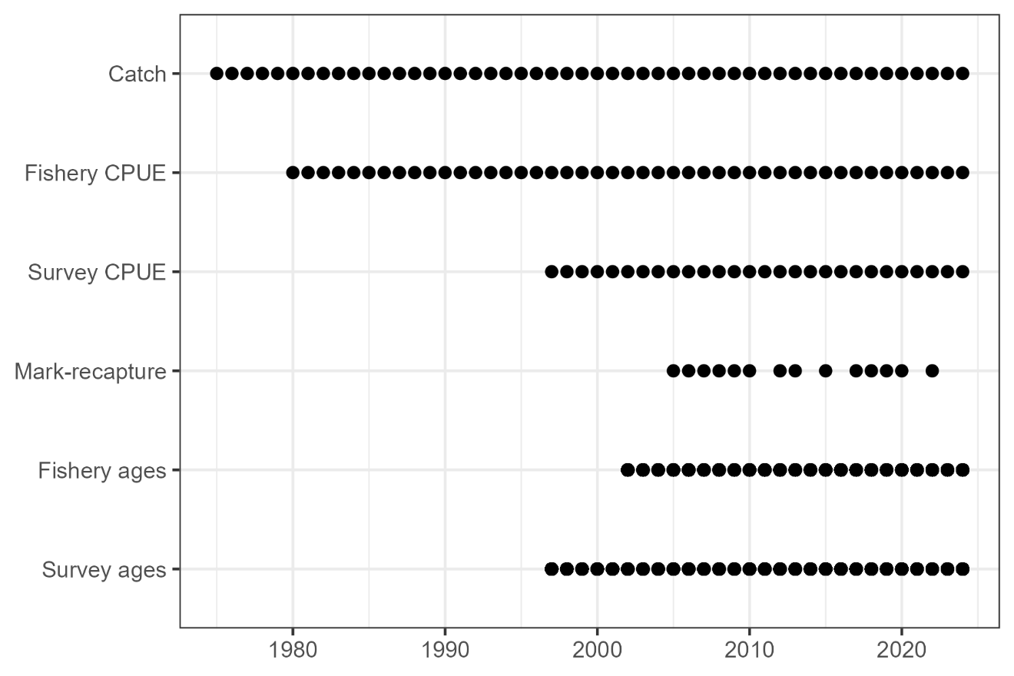
Appendix A3.–Summary of the available data sources in the Northern Southeast Inside (NSEI) Subdistrict by year.

IPHC-2019-SRB014-08, IPHC document database. 1932–. International Pacific Halibut Commission. Seattle, Washington. https://www.iphc.int/uploads/pdf/srb/srb014/ppt/iphc-2019-srb014-08-p.pdf (accessed July 2025).
Southeast Alaska Sablefish Github Repository. 2022–. Alaska Department of Fish and Game, Division of Commercial Fisheries. Sitka, Alaska. https://github.com/commfish/seak_sablefish (accessed July 2025).
(R Core Team 2024) R Core Team (2024). _R: A Language and Environment for Statistical Computing_. R Foundation for Statistical Computing, Vienna, Austria. <https://www.R-project.org/>.
Southeast Alaska Sablefish Github Repository. 2022–. Alaska Department of Fish and Game, Division of Commercial Fisheries. Sitka, Alaska. https://github.com/commfish/seak_sablefish (accessed July 2025).

